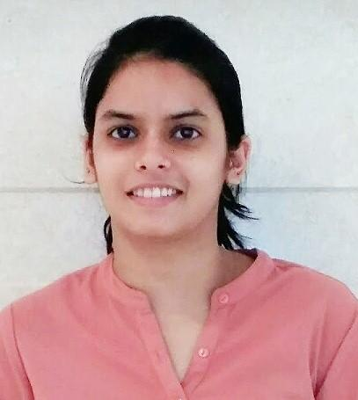

**CHARUL MAHUR**

D-3/40, Sangam Vihar  
 New Delhi-110080  
 Contact No.- 9811976798  
 Email: charulmahur03@gmail.com

## **Career Objective**

My vision is to seek the position of **Political Science/ Social Science Teacher** in an organization that will give me an opportunity to pass on my knowledge to the students in an innovative manner and to the best of my abilities and foster meaningful relationships with students and school personnel.

## **Educational Credentials**

| **Degree/ Certificate** | **School / College** | **University or Board** | **Year of** | | **Percentage** |
| --- | --- | --- | --- | --- | --- |
| **Entry** | **Leaving** |
| M.A. in Sociology | Akshay Pratishthan | IGNOU | 2018 | 2020 | 69.00% |
| B.Ed (Political Science and English) | Institute of Vocational Studies | Indraprastha University | 2017 | 2019 | 81.92% |
| M.A. in Political Science | Lakshmibai College | Delhi University | 2015 | 2017 | 58.6% |
| B.A.(H) in Political Science | Motilal Nehru College | Delhi University | 2012 | 2015 | 64.8% |
| Senior Secondary School | Balvantray Mehta Vidya Bhawan,GK-II | CBSE | 2011 | 2012 | 77.4% |
| Secondary School | Balvantray Mehta Vidya Bhawan,GK-II | CBSE | 2009 | 2010 | 74.1% |

**Achievements**

| **Qualifying Exam** | **Qualifying year** | **Marks obtained**  **(MM-150)** |
| --- | --- | --- |
| Central Teacher Eligibility Test-Paper 1 | July 2019 | **111** |
| Central Teacher Eligibility Test-Paper 2 | July 2019 | **103** |
| NPTEL Online Certification (INTELLECTUAL PROPERTY) | April 2020 | **81%** |

**Internship Experience**

| **Organization** | **Training Tenure** | **Details** |
| --- | --- | --- |
| Hamdard Public School ,Hamdard Nagar, New Delhi | 6th August to 21st December, 2018 | Teacher training:  Political Science in 11th and English in 7th using various teaching aids |

**Experience**

| **Organization** | **Tenure** | **Details** |
| --- | --- | --- |
| Summer Fields School, New Delhi | 9th January, 2020- till date | TGT (political science)  Teaching classes 10th, 11th and 12th |

**Projects**

* Research paper on “Availability of audio-visual aids in government school”**.**

**Volunteer Experience**

## Volunteered 5 months in Teaching at Shades of Happiness Foundation (St. Columba’s School, Ashok Place, New Delhi)

## Volunteered in various Polio Campaigns

## **Skills**

## Communication skills

## Interpersonal skills

## Basic computer skills (MS WORD, EXCEL, POWERPOINT) and Internet Operations

## Creating Blogs, Google Classrooms and E-portfolios

**Extra Curricular Achievements**

## Participated in Delhi 2010 CommonWealth Games (Dance competition)

## Won first prize in “Vivekananda Quiz”

## Participated in Chinmaya Youth Festival

## Been a part of Rotary Youth Club

## Been a part of the Discipline Committee as the Prefect

## Participated in debates and seminars

## **Personal Vitae**

Father’s Name : Mr. Satveer Singh Mahur

Date of Birth : 21 September, 1995  
Languages Known : English, Hindi

Sex : Female

Marital Status : Married  
Nationality : Indian

Strengths : Positive attitude, Quick learner, Self Improvement, Focused,

Punctual, Knowledgeable and Creative.

**Declaration**:  
I, Charul Mahur, hereby declare that all the information provided in my resume is true to the best of my knowledge.