**Resume**

**RESUME**

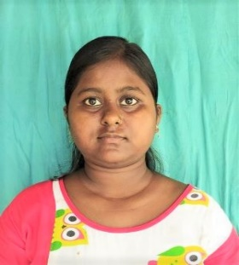**SUSMITA ROY**

 **9933787608**

** Susmitaroy81846@gmail.com**

** College more, Islampur, Uttar Dinajpur 733202**

**CAREER OBJECTIVE**

To have a career in a professional organization and put all my efforts into the growth of the organization and have a great working environment.

**Academic Qualification**

* **10th** pass from WB Board in 2013
* **12th** pass from WB Board in 2015
* Graduate with **B.sc(Mathematics)** from North Bengal University in 2019
* Post Graduation with **M.sc(Mathematics)** from North Bengal University in 2021
* **B.ED** from Baba Saheb Ambedkar Education University in 2023

**Technical Qualification**

* **12th month diploma in computer application**

**Experience**

* **Freshers**

**Personal Details**

**Name : Susmita Roy**

**Father’s Name : Late. Kartick Chandra Roy**

**D.O.B : 02/01/1998**

**Marital Status : Unmarried**

**P. Address : College more, Islampur, Uttar Dinajpur,**

**733202**

**Date:____________**

**Place:____________**