** RESUME**

**Subham Ghosh**

**Contact numbers –7584044760 and 9563928971**

**Email Address --** **subhammalda8@gmail.com**

**Career objective:**

To pursue a career that will enhance my education & professional qualification, which will provide ample opportunities for growth & a rewarding remuneration.

**Educational qualification:**

* In 2010 passed **Madhyamik Examination** from **Mahesmati D N Saha Vidyabhaban**
* In 2012passed **Higher Secondary Examination** from **J M S Hindi High School.**
* In 2015 **Graduation (B.A)** under **University of Gour Banga**

**Professional qualification:**

Completed CITA, DITA, TALLY. ERP 9 course .

**Computer knowledge:**

Have knowledge of computer about Fundamentals, DOS, Windows, MS-Word, Ms-Excel, Visual FoxPro, Visual Basic, Access, Flow Chart, Project Work, E-mail & Internet.

**Working experience:** 10 years job experience

1. Worked as the Marketing in charge of Sharekhan, Stock Market for 3 years in Malda.

2. Worked as a Merchantdiser of Nestle India Pvt. Ltd for 2 years in Malda.

3. Working as Marketing in charge & Admission in charge of Usha Martin School, Malda.

**Job responsibilities in Usha Martin School , Malda:**

1. Planning and preparing the Marketing Budget for the next academic session.
2. Selecting the hoarding sites and fixing the rates.
3. Selecting print media and fixing the rates.
4. Providing inputs to the design of the advertisement contents in flex, print media, brochures, folders etc.
5. Careful execution of the plan as per timeline.
6. Monitoring office staff involved in marketing.
7. Replying to online queries and walk-ins.
8. Selling the Prospectus.
9. Fixing the Admission Test Date and getting the answer script corrected by subject teachers.
10. Fixing the appointment for interaction with the Dean or the Principal**.**
11. Completion of admission procedure by handing over the approved Admission Form to Accounts Department with necessary documents as per CBSE guidelines.
12. Facilitating the parents of the newly admitted students to get the books, copies and uniform from the Books in charge and Dress in charge.
13. Explaining the parents of the newly admitted students about the bus routes and stoppages.
14. Coordinating with Transport in charge for creation of new stoppages within existing routes or creation of new routes in potential areas.
15. Collecting feedback after PTM.
16. Sending bulk SMS as per instruction from the Dean/ the Principal.
17. Tele-calling for depositing pending school fees as per Due List from Accounts Department.
18. Helping to organize the various “utsavs” in school as part of school curriculum- Rabindra Utsav (May), Mango Utsav (Utsav), Prakriti Utsav (July), Swadesh Utsav (August), Jantra Utsav (Sept), Ananda Utsav (Nov), Bhoj Utsav (Dec), Urja Utsav (Jan) and Basanta Utsav (March).
19. Coordinating with Accounts Department to deposit cash and cheques in the bank.
20. Coordinating with Books & Dress In-charge to collect them from the transport, to reconcile with the list and finally uploading the same in Tally.
21. Purchasing items for the school as per approval.
22. Helping IT Support Team to co-ordinate with parents in solving difficulties arising while executing the online teaching content for the children.
23. Maintaining a record of the names of the students with their phone numbers and e-mail ids.
24. Helping during TC formalities when students leave school.
25. Maintaining Drop Out List with reason for future use.
26. Facilitating payments to various vendors as per instruction from management.

**Personal Details:**

Date of birth: 15.01.1995

Nationality : Indian

Marital status: Married

Language Proficiency: English, Bengali and Hindi.

Permanent address:

S/O Late Gopal Ghosh

P.O. & Dist. - Malda

Pin code – 732101

**Declaration:** I hereby declare that all statement made in this resume are true complete & correct the best of my knowledge & belief.

Place :- Malda

Date :-

 ………………………………..

Signature

*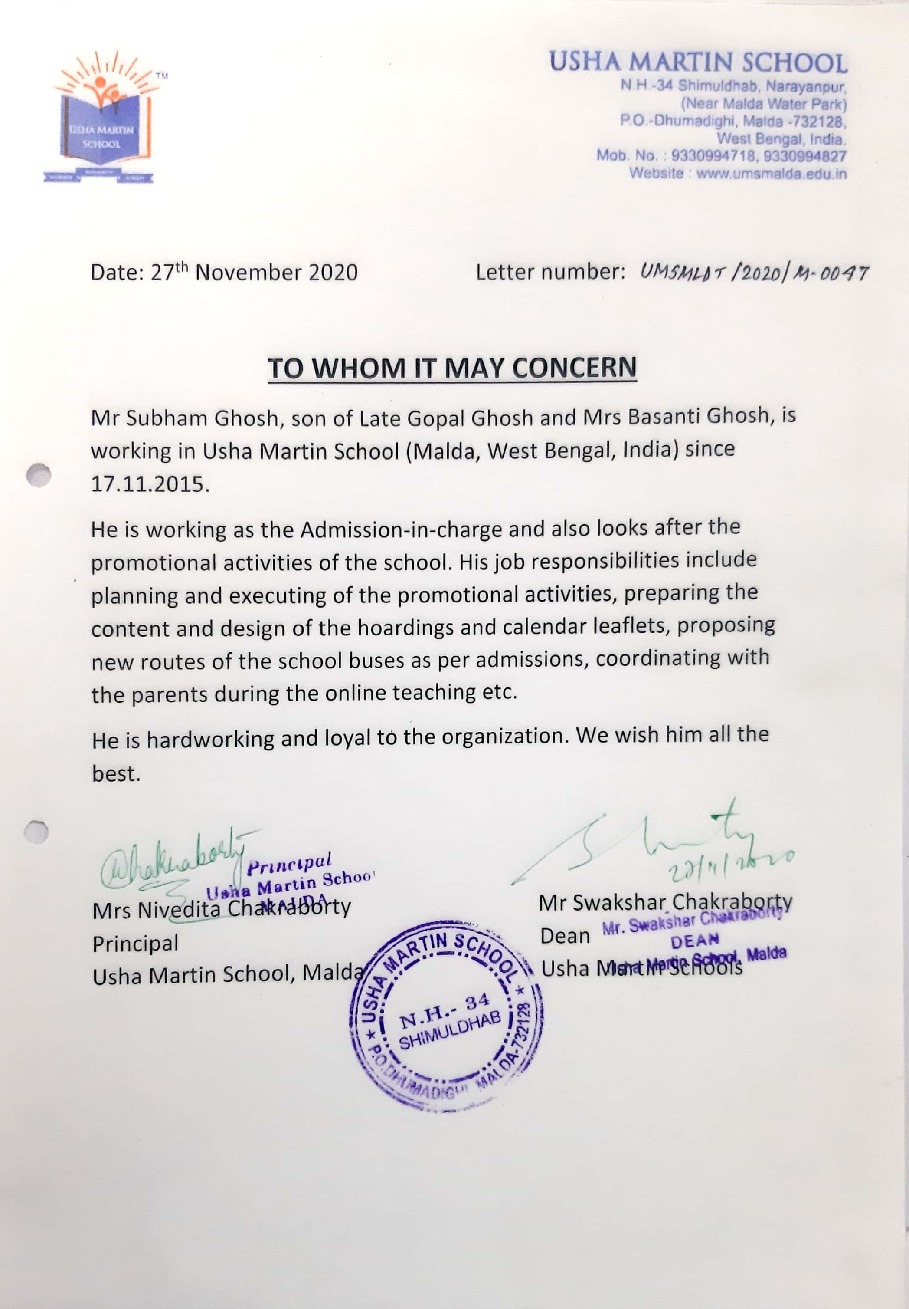Experience Certificate*