***Smita kumari***

. 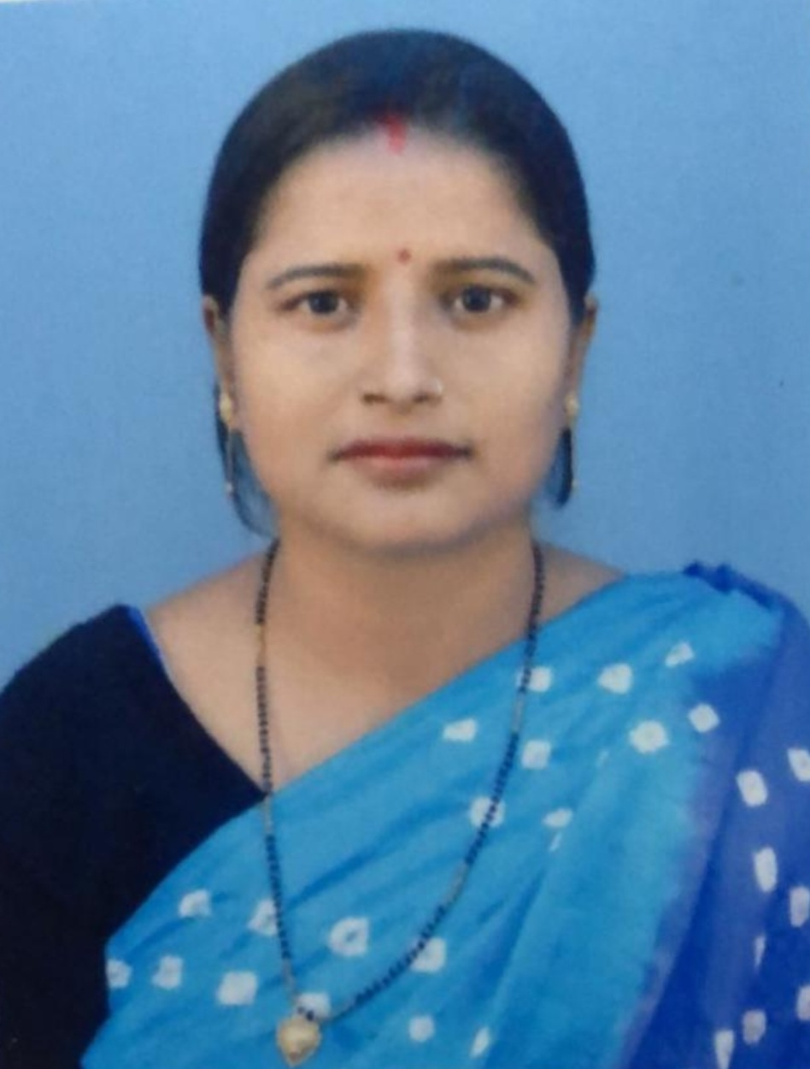 

***E-mail : smitaprakashvaibhav@gmail.com***

***Mobile: -8409219475***

***CAREER OBJECTIVE***

**Intend to build a career with growth oriented organization with committed & dedicated people, which will help me to explore myself fully and realize my potential. Willing to work as a key player in challenging & creative environment.**

***SYNOPSIS***

* **About 08 years of Teaching/Parenting experience of School.**
* **Organized and driven with the ability to stay on task and efficient methods of teaching whilst focusing on the individual needs of each student.**
* **Lesson Planning Expertise**
* **Class management**

***ORGANISATIONAL DETAILS***

**Currently Teaching at ACHARYA SUDARSHAN KRISHNA NIKETAN (Affiliated to CBSE upto +2) as a PRT at Transport Nagar, Bypass Road, Patna from 16th may 2021 to Till Date.**

***PREVIOUS ORGANISATIONAL DETAILS***

**Since 02nd May 2018 to 31st December 2020 with St. josheph high school (Affiliated to CBSE upto +2) as a Prt at Bhootnath ,Patna .**

**Since 13 th April 2006 to 30 th April 2011 with English central school (affiliated to cbse ) as a Prt at sighs Patna**

**Job Profile:**

* **Teaching with Caring.**
* **Academic Performance Evaluations.**

***ACADEMIC QUALIFICATION***

***10th* (2001) B.S.E.B from Rabindra balika vidyalaya , Patna.**

***12th (2003)* B.S.E.b (Patna university)B. N. College, Patna .**

***B.A*  (2007) FROM D.D.E UNDER Patna UniverSity , Patna .**

**M.A. (2016) from Nalanda open university, Patna**

**B.ed. (2018) from Magadh university, Gaya**

***PERSONAL DETAILS***

**Date of birth : 20 th march 1986**

**Present address : C/o Ashok Singh**

**Mokama house, opp of hanuman mandir**

**Bazar samiti road, Patna 800016**

**Husband name :Mr.Prakash Ranjan**

**Sex : Female**

**Marital status : married**

**Languages known : English, Hindi & local language.**

**Nationality : Indian**

**Declaration:**

**In hereby declare that the information furnished above is true to the best of my knowledge.**

**Date : 10.10.22**

**Place: Patna (Smita kumari )**