CURRICULUM VITAE

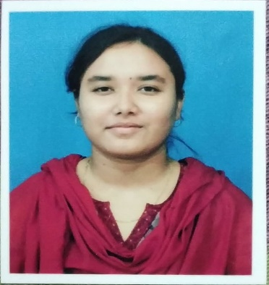**RAIHANA PERVEEN**

**M.A. HONS IN ENGLISH** Soleman Biswasspara,Vill+P.O Sujapur, P.S. Kaliachak, Dist- Malda. Pin-732206 [raihana.perveen24@gmail.c](mailto:raihana.perveen24@gmail.c)om Mob No :( +91)6291357837

(+91)7384433833

# CAREER OBJECTIVE

To work innovatively in an environment of challenge and growth, gain valuable experience, expertise in the area of operation as provided by the organization.

EDUCATIONAL QUALIFICATION

|  |  |  |  |
| --- | --- | --- | --- |
| **DEGREE** | **INSTITUTION / BOARD / UNIVERSITY** | **PERCENTAGE/CGPA**  **EXCEPT OPTIONAL SUBJECTS** | **YEAR OF PASSING** |
| Secondary  Examination | Kendriya Vidyalaya NO.1 DHANBAD JHARKHAND  (CBSE) | ***8.2 CGPA*** | ***2013*** |
| Higher  Secondary Examination | Kendriya Vidyalaya NO.1  DHANBAD JHARKHAND (CBSE) | ***66.80*** | ***2015*** |
| B.A. Hons In English | INDIRA GANDHI NATIONAL OPEN UNIVERSITY (IGNOU) | ***55.00*** | ***2018*** |
| M.A Hons In English | INDIRA GANDHI NATIONAL OPEN UNIVERSITY (IGNOU) | ***53.00*** | ***2021*** |
| B.ED  (TEACHING COURSE) | KALIACHAK SULTANA COLLEGE OF EDUCATION (BABA SAHEB AMBEDKAR UNIVERSITY) | ***_*** | ***PURSUING*** |

# CTET Paper - I Qualified - 57%

# 

* + **Basic Knowledge Of Computer Application**

**EXTRACURRICULAR ACTIVITY :** *Sports and drawing.*

***STRENGTH*** : Ableto work with minimal supervision, Ability to master new skills quickly.

**ACHIEVEMENTS :** Participated in sports event and won prizes in schools.  **HOBBIES :** Drawing, Listening to Music, Travelling

# PERSONAL PROFILE

|  |  |
| --- | --- |
| **NAME:**  **DATE OF BIRTH:**  **FATHER’S NAME: SEX:**  **MARITAL STATUS: LANGUAGES KNOWN:**  **NATIONALITY: PERMANENT ADDRESS:** | Raihana Perveen  15/03/1998 MD. Abdur Rouf Female  Married  English, Hindi, Bengali Indian  Vill + PO – Sujapur, P.S. Kaliachak  Dist –Malda. PIN - 732206,  West Bengal (India) |

DECLARATION:

I do hereby declare that the above particulars are true to the best of my knowledge and belief and I would be glad to provide any other necessary information.

**Date:** ------------------------------------- Raihana Perveen