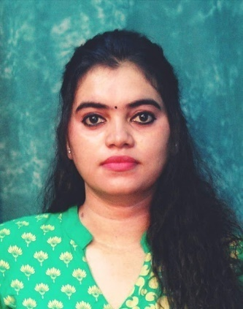

**Maris Jana Daniel`**

**G2 hari hana apartment, ground floor**

**Wahab st, choolaimudu**

**Phone: 7550103404/9884543804**

**Email: dmarisjana@gmail.com**

**CAREER OBJECTIVE:**

To work as a Montessori teacher and serve as a guide and mentor for children and to help them build confidence by engaging them in fun and practical activities.

**SUMMARY OF SKILLS:**

* Excellent knowledge of Mother Montessori style of teaching
* Thorough knowledge of children's growing needs
* Full of enthusiasm and brimming with new ideas for teaching children
* Ability to guide and assist children learn new things daily
* Skilled in keeping record and tracking progress in children
* Mature and professional in building rapport with children, parents, and staff.

**WORK EXPERIENCE:**

|  |  |  |
| --- | --- | --- |
| **COMPANY** | **DESIGNATION** | **YEAR EXPERIENCE** |
| ***The Nature School*** | ***Teaching faculty*** | ***2016*** |
| ***Joy kids school*** | ***Teaching faculty*** | ***2018-2019*** |
| ***Geetha matriculation hr sec school*** | ***Teaching faculty*** | ***2019-2020*** |
| ***MKM matriculation hr sec school*** | ***Teaching faculty*** | ***2020-2022*** |
| ***St,. Michael's academy*** | ***Teaching faculty*** | ***2022-2023*** |

**EDUCATION:**

|  |  |  |
| --- | --- | --- |
| **UNIVERSITY** | **COURSE** | **YEAR** |
| Patrician college of art and science | B.Sc. Visual communication | 2009-2012 |
| SRM University | M.A journalism & mass communication | 2012-2014 |
| 2014-2016 |
| Sri Venkateswara Montessori Teachers Training School | FICS UK (Forum for International Certified Scholar) | 2018-2019 |

**SKILL:**

|  |  |  |  |  |
| --- | --- | --- | --- | --- |
| **Language** |  |  | |  |
| **English** | **Read** | **Write** | | **Speak** |
| **Tamil** | **Read** | **Write** | | **Speak** |
| **Mayalam** | **-** | **-** | | **Speak** |
|  | | |

**SOFTWARE:**

|  |  |  |
| --- | --- | --- |
| **S.no** | **Software** | **Level of competency** |
| **1.** | Adobe Illustration | **Good** |
| **2.** | Auto Photoshop | **Good** |
| **3.** | Web designing | **Good** |

**ADDITIONAL COURSE**

|  |
| --- |
| * Graphic Designer * Photographer * Handcraft makes * Jeweler designing * Interior designing |

**EXTRACURRICULAR ACTIVITIES:**

* Playing Games, Bharatanatyam, Reading books, Listening music, Ads editing & Art and craft .
* ATHLETIC 100mt (State), THROW BALL (National)

**PERSONAL DETAILS:**

* NAME. : MARIS JANA DANIEL
* DATE OF BIRTH. : 21/11/1989
* FATHER NAME. : AUGUSTINE S SINDHATHUARI
* MOTHER NAME. : MARY RAJILLA
* LANGUAGES KNOWN. : ENGLISH & TAMIL
* NATIONALITY : INDIAN
* MARITAL STATUS TAMIL & : MARRIED

**Thanking you**

**Maris Jana Daniel**

Place: Chennai.