BIO – DATA
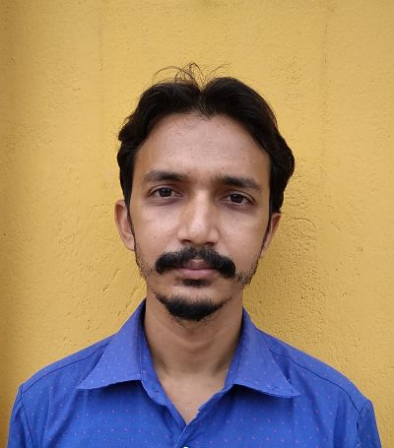

1. NAME : PARTHA PRATIM KARMAKAR

2. FATHER’S NAME : PANKAJ KUMAR KARMAKAR

3. ADDRESS : C/O PANKAJ KUMAR KARMAKAR
VIVEKANANDA PALLY
P.O.- MANGALBARI
MALDA
WEST BENGAL.
732142

4. CONTACT NUMBER : 7001637953

6. EMAIL ID : karmakarparthapratim3@gmail.com

5. SEX : MALE

6. DATE OF BIRTH : 30/06/1987

7. MARITAL STATUS : MARRIED

8. LANGUAGES KNOWN : ENGLISH, HINDI, and BENGALI

9. RELIGION : HINDU

10. NATIONALITY : INDIAN

11. EDUCATIONAL QUALIFICATION :
NAME OF THE EXAMINATION | BOARD/COUNCIL/UNIVERSITY | YEAR OF PASSING | DIVISION/MARKS/  PERCENTAGE | PERCENTAGE (%)
MADHYAMIK | W.B.B.S.E. | 2003 | 1ST | 66.25
H.S. (COMMERCE) | W.B.C.H.S.E. | 2005 | 1ST | 60
B.COM(Honours) | N.B.U. | 2009 | 2ND | 55
B.ED (Work Education) | HIMACHAL PRADESH UNIVERSITY | 2015 | 1ST | 61.27
Bachelor of Library science(B.LIS) | PERIYAR UNIVERSITY | 2012 | 1ST | 68
12. EXTRA QUALIFICATION : 7TH YEAR DIPLOMA IN PAINTING from Bangiya sangeet parisad, Diploma in software application from webel.

13. WORK EXPERIENCE : I have an experience as a librarian in Delhi world public school… I also have 10 years work experience as a drawing teacher in a public school….I have an art school at my home named SRISTI ART ACADEMY. Registration no.-588

DATE : 28-Jul-26
PLACE : Malda
----------------------------------------------------
SIGNATURE

