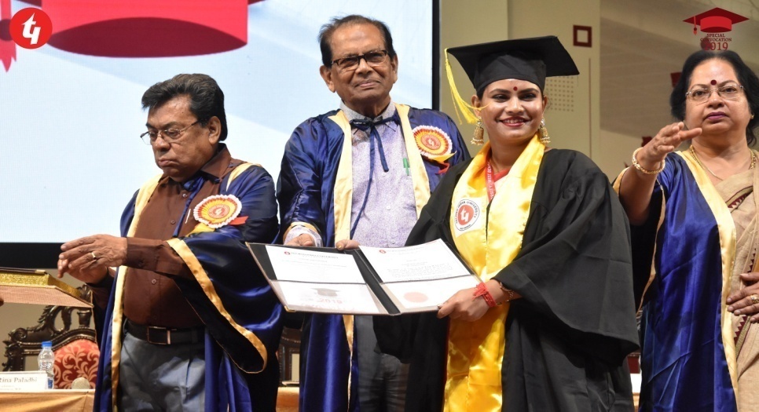
Madhurima Halder
[M-Tech ,Computer Science Engineering]
Educator, Faculty: Web Development, AI, ML
Internship : Data Science

Email id: maddy.indi@gmail.com
Phone no: +91 6290581890
Address: Salt lake, Sector-1, Kolkata-700064
Objective:
To gain more knowledge and experience by getting associated with a well established organization, which will help me with my growth. And elevate my skills.

Education:
- Techno India University:
Integrated B-Tech and M-tech (2014-2019)
Computer Science Engineering
CGPA:8.08
SGPA: 9
- Biddhannagar Govt High School: (2014)
(West Bengal council of Higher Secondary Education)
Higher Secondary
Percentage: 59%
- Begum Rokeya Memorial School: (2012)
(West Bengal Board of Secondary Education)
Madhyamik Exam
Percentage: 77%

Skills and Knowledge:
Artificial Intelligence Machine Learning Python Data Science
Html/Html5 Java Script CSS ANN
Robotics OOPS Node.Js Bootstrap
Visual Studio Anaconda Jupiter Notebook

Experience:

Eggheads Edu pvt ltd:

ICT Teacher
[February 2022 to present]
Teaching from grade 4-8
Cambridge curriculum [Also have knowledge of CBSE, ICSE,WBBSE ]

Toppr Technologies pvt ltd:

Coding Instructor
[07/2020 to 01/2022]
Faculty: Web Development, AI, ML, Python

Funscholer innovations pvt ltd:

R&D Engineer
[Till 07/2020]
Working on New Ideas
Coming up with new concepts
Creating Contents

Perennation Computer Solutions Global pvt ltd:

Internship in Data Science
[08/2018-09/2018]
Learning Data Visualization and Analysis
Using Pandas, Matplotlib etc.

Certifications:
- Geospatial Intelligence International Symposium
- World Wide Data Science Course
- Data Science Internship
- Java Training
- Gaming with Python
- SAP training

Projects and Final year Thesis:

THESIS TOPIC:
Tsunami Detection and Prediction System (2019).
By understanding Geomagnetic shift of earth, we are able to detect if another tsunami will be upon us. Using Image Segmentation we could tell how much area is going through the huge geomagnetic shift, and which are in danger zone. By utilizing more data we can further Understand and predict the nature of the shift and how big of an impact it could have.

SEMINER TOPIC:(Speaker) (2018)

Human health monitoring system using IOT.

In Recent times it has become more important to keep monitoring our vitals, especially for the senior citizen living alone. Thus a system which can keep the health care professionals updated about the conditions of their patents when then are living in home is very important. The IOT can provide a big game changing moment if based on the vitals automatically ambulance could be called and hospitals could be alerted.

SOLER BACED LED STREET LIGHT MOTION DETECTOR: (2015)
A huge amount of electricity is wasted in lower traffic area. To combat that we created a prototype of a system through which lights will only light up if someone is passing.
Basically Infrared LED will be triggered as someone is passing and The light will Glow up nearby.

MORSE CODE GENERATOR USING ARDUINO UNO: (2016)
We used the Uno board to generate the morse code by sensors. The code was uploaded in the Uno to recognize the pattern.

ONLINE TICKET BOOKING SYSTEM: (2017)
For the online Ticket Bookin system I worked on the front end, to have the best UX and have a good UI as well.
Referance:

Name: | Shobana Satyamurti
Organization: | EggHeads Education
Position: | Principle
Phone Number: | +91 88929 24955
Email: | shobana_saanvi@yahoo.com

Name: | Urvi Shah
Organization: | Toppr Technologies
Position: | Techer Manager
Phone Number: | +91 99676 05620
Email: | urvi.shah@toppr.in

