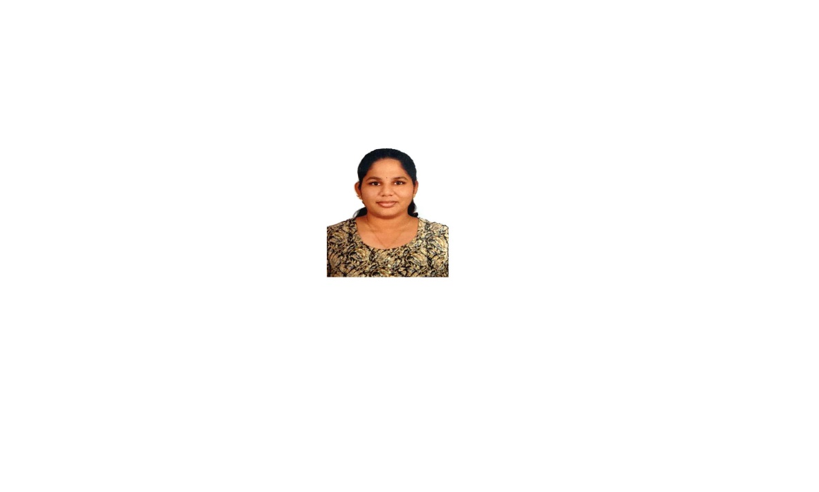No. 3/22, Krishnaswamy street,

**CURRICULUM VITAE**

Palavanthagal, Chennai 600 114.



+91 9789020797



Shanmathi Chittibabu

[shanmathichittibabu@gmail.com](mailto:shanmathichittibabu@gmail.com)

**PERSONAL DETAILS** Date of Birth: 03.01.2001

Gender: Female

Nationality: Indian

**EDUCATION** Master of Science (M.Sc.), Plant Biology and Plant Biotechnology

Madras Christian College (University of Madras), Chennai.

August 2021 – April 2023

**Percentage: 72.4%** (Overall percentage till 3 rd Sem)

Bachelor of Science (B.Sc.), Plant Biology and Plant Biotechnology

Madras Christian College (University of Madras), Chennai.

June 2018 – May 2021

**Percentage: 68.3 %**

Higher Secondary (XII STD), State board.

Sitadevi Garodia Hindu Vidyalaya (S.G.H.V) Mat. Hr. Sec. School,

Tambaram East, Chennai.

March 2018

**Percentage: 72.1%**

Secondary School (X STD), State board.

Sitadevi Garodia Hindu Vidyalaya (S.G.H.V) Mat. Hr. Sec. School,

Tambaram East, Chennai.

March 2016

**Percentage: 94.8%**

**WORKSHOPS Eppendorf India PVT LTD - 2023**

Latest Technologies and Products of Bio- Tech/ Lab Research Instruments.

**ECO WORKSHOP – 2017**

Indigenous and Frontier Technology Research Centre, Chennai.

**WEBINAR Webinar Series 2022 – Frontier Technologies in Plant science**

Department of botany, Madras Christian college, Chennai.

**INTERNSHIPS Internship Training programme in Pharmacognosy**

Siddha Central Research Institute (CCRS, Chennai and Ministry of Ayush, Govt. of India), Anna Govt. Hospital Campus, Chennai.

**INSPIRE – Internship Camp**

Science camp under inspire internship scheme, K.S.R College of Technology, Tiruchengode.

**PROJECT PHYTOLITH ANALYSIS FROM THE FECAL PELLET OF**

**NILGIRI TAHR** (***Nilgiritragus hylocrius***Ogilby, 1838)

Under the guidance of Dr. Selva Singh Richard, MCC.

**TECHNICAL SKILLS** Palynology: Extraction of Phytolith and identification of phytolith

morphotypes, Pollen collection, Isolation, and storage of pollen.

Plant tissue culture: Maintaining aseptic condition, Instruments handling, Sterilization, Culturing techniques, Media preparation, Lab designing.

Herbarium Techniques, Preparation of slides for SEM & TEM, Basic knowledge on Algae collection

**Computer skills**: MS Office, Adobe photoshop 2023.

**ACHIEVEMENTS SUBJECT TOPPER – TAMIL** (SSLC – MARCH 2016)

School first in Tamil.

2 nd Place in Throw ball Intra department event (2021- 2022),

Botany Society, MCC.

2 nd Place in Throw ball Intra department event (2022- 2023),

Botany Society, MCC.

Qualified for the City Finals of Times NIE Think and learn Challenge

2015 – 2016.

Participated in School level Science Quiz - 2013 by FIITJEE.

**LANGUAGE KNOWN** English, Tamil, Telugu.

**Declaration**,

I do hereby declare the truth and authenticity of all the information in my resume.

**Place**: Chennai **Date**: 06.05.2023