**BIO DATA**

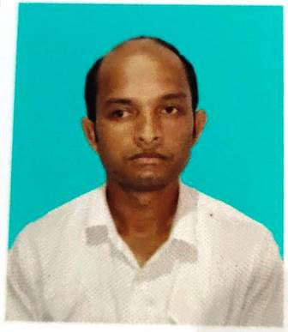

Name : **BABU MONDAL**

Father’s Name : MOIJUDDIN AHMED

Mobile : 7384311835

Gender : MALE

Date of Birth : 17/02/1993

Marital Status : MARRIED

Religion : ISLAM

Nationality : INDIAN

Education Qualification :-

|  |  |  |  |  |  |
| --- | --- | --- | --- | --- | --- |
| NAME OF THE EXAMINATION | BOARD/UNIVERSITY | YEAR OF PASSING | TOTAL MARKS | MARK OBTAIN | PERCENTAGE |
| MP | WBBSE | 2009 | 800 | 412 | 51.5% |
| H.S | WBCHSE | 2011 | 500 | 268 | 53.6% |
| B.A(Bengali Hons) | WBNSOU | 2020 | 800 | 475 | 59.38 |
| BLIS | WBNSOU | 2021 | 800 | 669 | 83.38% |

Address :

**VILL+P.O-BARALA**

**P.S-RAGHUNATHGANJ**

**DIST-MURSHIDABAD**

**PIN-742235**

Declaration

I hereby declare that all the information provided here is true to the best of my knowledge.



Place:-Barala

Date:-25/09/2023 Signature.