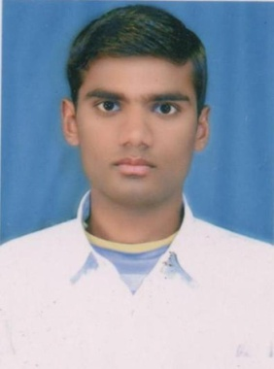**CURRICULUM – vitae**

**MD SAZZAD ANSARI**

**m**

VILL-Kalchini T.E Masjid Line

Alipurduar-735217

West Bengal India

Email-sazzada376@gmail.com

**Contact:-91+7797849325/91+9733263972**

**_________________________________________________________________________________**

**Objective**:

To invest time and energy to meet in the need of the organization to achieve a meaningful position, which enables to be a better team member and manage things in a more effective and productive manner for the growth and prosperity of the organization.

***EDUCATION QUALIFICATION***

|  |  |  |  |  |
| --- | --- | --- | --- | --- |
| Sl No | Name of Class | Name of Board | Passing Year | Percentage |
| 01 | MA | NBU | 2016 | 54.25% |
| 02 | BA (Hons) | NBU | 2014 | 49% |
| 03 | H.S | WBCHSE | 2011 | 53% |
| 04 | M.P | WBBSE | 2008 | 55% |
| 05 | B.ED | WBUTTEPA | 2018 | 69% |

***EXTRA QUALIFICATION***

* Tally Course from Rashtriya Computer Literacy Drive (RCLD Kalchini)
* B.ED Degree from The West Bengal University of Teachers’ Training Education Planning & Administration (WBUTTEPA University from Kolkata)

***COMPUTER SKILLS***

* Data Entry, Typing with speed 40wpm.
* Data Analysis: Microsoft Office.
* Internet, E-mail etc.

### *JOB EXPERIENCE:* OMEGA English Academy and Montessori, KALCHINI

**:** Class- 9 and 10

**:** Subject- Hindi

**:** Duration- 5th Jan 2022 to 29th Dec 2022

### *PERSONAL DETAILS*

* Name **! MD SAZZAD ANSARI**
* Date of Birth **!** 19th July 1992
* Marital Status **!**  Single
* Nationality ! Indian
* Religion ! Islam
* Sex **!** Male
* Language Known **!** English, Hindi, Bengali, Urdu, Sadri,Nepali.
* Physical Status **!** Height: 5’5’’ Weight : 50kg

***DECLARATION***

I hope that your consideration will be beneficial for my bright future. If you will give a chance to express my ability. I assure you that I would be honorable and thankful for you. I hereby declare that the above particulars are true & complete to the best of my knowledge.

Date: 02-09-2023 **Yours’ faithfully,**

Place: **Kalchini**  Md Sazzad Ansari