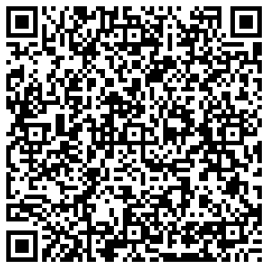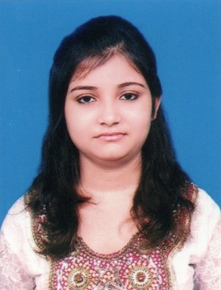



**taniyachatterjee123@gmail.com**



**+91 8240274996**

**TANIYA CHATTERJEE**

Social Science Teacher (ICSE, CBSE, WBBSE)

**ABOUT ME**

**WORK EXPERIENCE  
6.5 Years**

As a human being, I want contentment through my perfection in my activities & clarify in a successful life, the foundation of which lies within the code of morality.

**AGE  
27**



**Education**

**M.A. in Psychology** AppearingAsutosh College Session: 2022-24  
IGNOU   
Kolkata, West Bengal

**B.Ed.** August 2021Santipur B.Ed. College Marks : 89.70%  
W.B.U.T.T.E.P.A. Division/Class : 1st   
Santipur, Nadia, West Bengal

**D.El.Ed** July 2019Rishi Arabinda College of Education Marks : 84.00%  
N.I.O.S. Division/Class : 1st  
Krishnagar, Nadia, West Bengal

**M.A. in Education** July 2018Main Campus Marks : 64.87%  
University of Kalyani Division/Class : 1st  
Kalyani, Nadia, West Bengal

**B.A. in Education(Hons.)** July 2016Kalyani Mahavidyalaya Marks : 61.00%  
University of Kalyani Division/Class : 1st  
Kalyani, Nadia, West Bengal

**10+2 (Higher Secondary)** May 2013Sarat Kumari Girls High School Marks : 70.40%  
W.B.C.H.S.E. Division/Class : 1st  
Santipur, Nadia, West Bengal

**10th (Madhyamik)** May 2011Sarat Kumari Girls High School Marks : 76.84%  
W.B.B.S.E. Division/Class : 1st  
Santipur, Nadia, West Bengal



**Career Highlights**

To be a dynamic professional in my chosen field and work to the full of my abilities and to build a symbolic relationship with my organization. Looking forward to an organization having professional outlook, believing in teamwork and goal orientation and having career plans for its employees.



**Skills**

* Classroom Management
* Fluently Spoken English
* Time manager
* Quick learner
* Team worker
* Record Keeping
* Lesson Plan Creation
* Punctuality
* Conflict Resolution



**Work Experience**

* **December 2019 – Till Date**  
  PG Teacher  
  **St. Mary’s Group of Institutions**  
  Ranaghat, Nadia, West Bengal
* Class-XII Education Teacher
* Class-XI Education Teacher
* Class Teacher- Class-X
* Social Science Teacher- Class-IX/VIII/VI
* **October 2018 – November 2019**  
  Assistant Teacher  
  **Santipur Public School**  
  Santipur, Nadia, West Bengal
* Class Teacher- Class-X
* Social Science Teacher- Class-IX/VIII/VII/VI
* **April 2016 – September 2018**  
  Assistant Teacher  
  **Santipur Kidzee**  
  Santipur, Nadia, West Bengal
* Class Teacher- Sr. Kg.
* Class Teacher- Jr. Kg.
* Administrator



**Computer Proficiency**

* Basic & Fundamental Knowledge
* Operating System (Windows XP/Vista/7/8/8.1/10/11)
* Microsoft Word 2003/2007/2010/2013/2019
* Microsoft Excel 2003/2007/2010/2013/2019
* Microsoft Power Point 2003/2007/2010/2013/2019



**Languages**

* English
* Bengali
* Hindi



**Personal Interests**

* Reading Books
* Internet Surfing
* Listening Music
* Watch Movie
* Travelling
* Photography



**Personal Details**

Father’s Name: Late Samir Chatterjee Marital Status: Married  
Birthday: March 27, 1995 Nationality: Indian  
Gender: Female Religion: Hinduism

Category: General Current Address : 21, Puin Para Lane

P.O. & P.S. – Santipur,

Dist. – Nadia,

Pin – 741404

**Declaration**

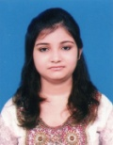I, Taniya Chatterjee, hereby declare that the information contained herein is true and correct to the best of my knowledge and belief.

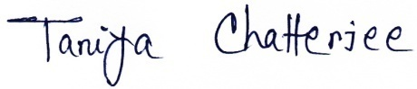

____________________________  
Taniya Chatterjee Santipur, Nadia  
 October 11, 2022