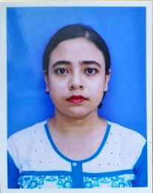**CURRICULUM VITAE**

**Name-** BIPASHA MUNSHI

**Phone no**- 7431030608

**Email id**- [bipashamunshi1997@gmail.com](mailto:bipashamunshi1997@gmqil.com)

**ACADEMIC QUALIFICATION**

|  |  |  |  |  |
| --- | --- | --- | --- | --- |
| **Course** | **College** | **Year** | **University/board** | **Percentage** |
| Secondary | Barlow Girls’ High School | 2014 | WBBSE | 71.28 |
| Higher Secondary | Barlow Girls’ High School | 2016 | WBCHSE | 83.60 |
| Bachelor of arts (Bengali Honours) | Malda College | 2016-2019 | UGB | 54.45 |
| Master of arts (Bengali) | Malda college | 2019-2021 | UGB | 79.50 |
| Bachelor of Education | Govt Teachers Training College,Malda | 2021-2023 | WBUPPTA | Pursuing |

**EXTRA CURRICULAR ACTIVITY**

1. Diploma In Information Technology Application- (MS Word,Excel,Power Point)
2. SHILPA RATNA In Drawing
3. SHILPA VISHRAD In Rabindra Sangeet

**LANGUAGE PROFICIENCY**

1. Bengali (Reading,Writting,Speaking)
2. English (Reading,Writting,Speaking)

**PERSONAL INFORMATION**

* Date of Birth - 20TH September,1997
* Father’s Name- Chandan Munshi
* Mother’s Name- Beauty Munshi
* Residential Address- Air View Complex, Opposite ITI College, Malda, WB