**RESUME**

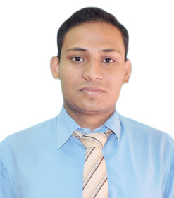

**Name** : Swastyaneek Prajna Prabak

**Address** : Durgapur,Paschim Bardhaman, WB

**Mobile**  :8538026913

**Email** :bapidgp95@gmail.com

**OBJECTIVE:**

My objective is to become associated with an organization where I can utilize my skills and gain further experience while enhancing the organization’s productivity and reputation.

**EDUCATIONAL QUALIFICATION:**

|  |  |  |  |
| --- | --- | --- | --- |
| **Examination** | **Board/University** | **Year of passing** | **Percentage** |
| **BLIS** | IGNOU | 2021 | 63% |
| D. El. Ed. | WBBPE | 2022 | 85% |
| B.Ed. | BU | 2019 | 60% |
| B.C.A | M.A.K.A.U.T | 2017 | 74% |
| H.S | W.B.C.H.S.E | 2014 | 55% |
| Madhyamik | W.B.B.S.E | 2012 | 81% |

**INDUSTRIAL TRAINING: (MINOR PROJECT)**

* Organization : Flexonlabs (Durgapur)
* Project Undertaken : “**eCARE**”
* Language : PHP with mysql

**MAJOR PROJECT:**

* Project Undertaken : ‘**Online Volvo Bus Ticket Booking’**
* Language : PHP with mysql

**STRENGTHS:** Hard Working, Willingness to learn, Adaptability, Leadership quality.

**INTERESTS:** Listening songs and watching TV, Swimming , Travelling , Computer.

**COMPUTER AND LANGUAGE SKILLS:** Microsoft Office ,C Language ,Object Oriented Programming C++, DBMS, HTML, PHP, Data Structure.

**PERSONAL DETAILS:**

Date Of Birth : 21st Oct 1995

Permanent Address : Durgapur, Paschim Bardhaman , WB

Gender :Male

Nationality :Indian

Languages Known : Bengali, Hindi and English

Blood Group :B+

Marital Status :Single

**DECLARATION:**

I do hereby declare that the above statements are true and correct to the best of

my knowledge and belief.

DATE : 25/9/2023

