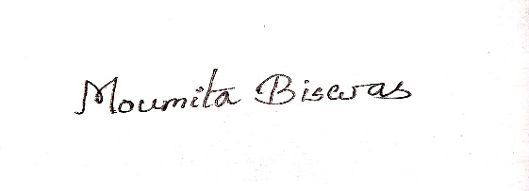

|  |  |  |  |  |  |  |  |
| --- | --- | --- | --- | --- | --- | --- | --- |
| **MOUMITA BISWAS****MOUMITA.BISWAS0231@GMAIL.COM****8145599529 / 8013160250**   |  | | --- | | **Objective** To secure a challenging position that utilizes my years of experience, while allowing me the opportunity to grow professionally | | **Skills** Diploma in Computer Application  Certificate of Participation : National Level Seminar  Topic- Bibhuti Bhushan Bandyopadhay, Pakuahat Degree College, Malda | | **ATTRIBUTES** HARDWORKING  CREATIVITY  POSITIVE | | |  | | --- | | Research Experience2017-2023 : Ph.D ResearcherTilka Majhi Bhagalpur UniversityBhagalpur, Bihar | | **Education**2011- 2013 : Mastersin Arts (Bengali Hon’s) 64.50%Womens College, Malda2010- 2011 : Bachelor of Education 59.70%Satish B.ed College, Malda2006- 2009 : Bachelor in Arts (Bengali Hon’s) 52.38%Womens College, Malda2006 : Higher Secondary (WBCHSE) 57.20 %Jalalia Girls High School, Malda2004: Madhymik (WBBSE) 50%Jalalia Girls High School, Malda | | **PERSONAL INFO** W/O :Md. Azaharuddin  Add:Mahesmati,  P.S- English Bazar, P.O- Malda , Pin- 732101  D.O.B: 03.04.1988  Religion: Muslim  Maritial Status: Married  Language: Bengali, English, Hindi |   C:\Users\Sazz\AppData\Local\Microsoft\Windows\INetCache\Content.Word\pIC.JPG |

*SIGNATURE*