**BUSHRA KHATOON** 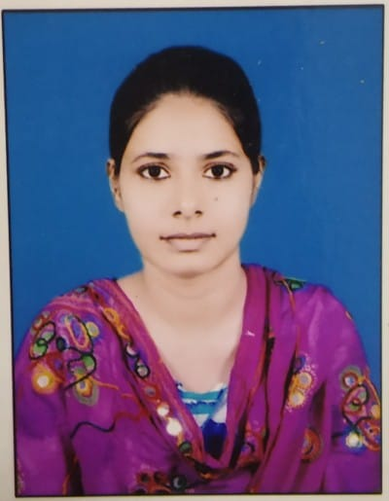

**Mobile: +91-6299103118  
E-Mail: [khatoonbushra84@gmail.com](mailto:khatoonbushra84@gmail.com)**

**CAREER OBJECTIVE**

* I am Masters in English Looking for teaching position.
* I would like to utilize my skills and experience as well as my passion for teaching to train and educate young minds.

|  |
| --- |
| PROFESSIONAL EXPERIENCE |

* Home Tutor

|  |
| --- |
| BRIEF OVERVIEW |

* **Ability to multi-task, work under tight deadlines and also work with minimal supervision.**
* **Efficient analytical & planning skills with abilities in working in teams for achieving organizational goals.**

|  |
| --- |
| ACADEMIA |

|  |  |  |  |  |
| --- | --- | --- | --- | --- |
| **Qualification** | **University/ College/ Board** | **Stream** | **Batch** | **%** |
| B.Ed | Shine Abdur Razzaque Ansari Institute of Health Education & Research Center | English,  Economic | 2020-22 | 82.69 |
| Post-Graduation | Marwari College Ranchi  (Ranchi University) | English | 2018-20 | 64.56 |
| Graduation | Marwari College Ranchi  (Ranchi University) | English | 2015-18 | 64.19 |
| 12th | St. Xavier’s College Ranchi  (JAC Board) | Arts | 2013-15 | 62 |
| 10th | Carmel School Ranchi  (ICSE Board) | Physics, Chem, Maths, Science, Social Science, Hindi, English | 2013 | 65.6 |

|  |
| --- |
| COMPUTER PROFICIENCY |

* **MS Office 2000-2010**
* **Internet Application**
* **Basic Knowledge of HTML.**

|  |
| --- |
| HOBBIES |

* **Reading**
* **Cooking**

|  |
| --- |
| STRENGNTH |

* **Self Confidence**
* **Positive Thinking**

|  |
| --- |
| PERSONAL DETAILS |

**Father’s Name : Taufique Quraishi**

**Date of Birth : 17th May 1996**

**Languages Known : Hindi, English, Urdu**

**Marital Status : Unmarried**

**Address : Kantatoli Purulia Road**

**Near Sharma Building**

**Ranchi 834001**

|  |
| --- |
| DECLARATION |

**I consider myself familiar with professional aspects. I am also confident of my ability to work in a team.**

**I hereby declare that the information furnished above is true to the best of my knowledge.**

***Signature:***

**Bushra Khatoon**