MADHUMAY PAUL 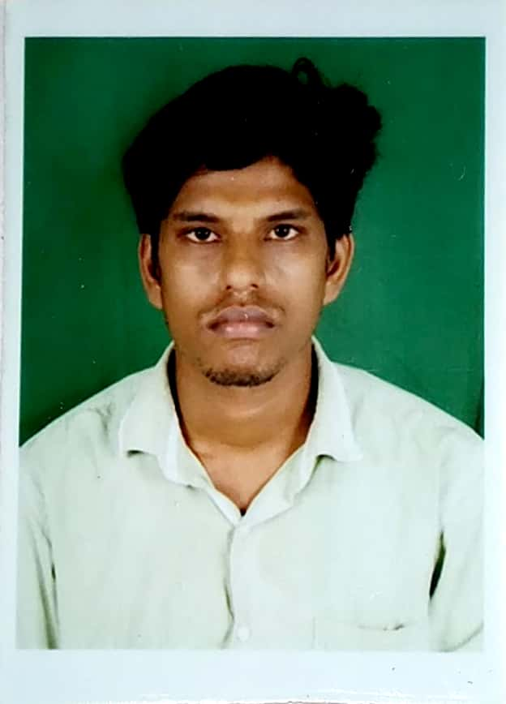

Vill-Nageshwarpur
P.O-Nageshwarpur
Dist-Malda
PIN - 732142

Mob  7001858126
-9733239012

E-mail: madhumaypaul290@gmail.com

Academic Qualification

- 10th from West Bengal Board of Secondary Education in the year 2007 (53.87%)
- 12th from West Bengal council of Higher Secondary Education in the year 2009 (58.60%)
- B.A (History Hons. with pass sub Bengali, Political science) from University of Gourbanga in the year 2012 (46.87%)
- D.el.ed from N.C.T.E affiliated college in the year 2019- 2021 (final year appearing).
- Diploma in computer application.

Work and Experience

I have 2 years experience as a private teacher of History subject.

About Myself
Sex: Male.

Marital Status: Unmarried

Nationality: Indian.

Religion: Hindu

Languages Known: English and Bengali
Mother 's name Chandana Paul
Date of Birth: 6th May 1990
DECLARATION: -
I consider myself as an honest, hard working teacher come motivator and from good qualified experienced background. I am also confident of my ability to work in the teaching field to educate the new generation.
DATE : 25/07/2021 -----------------------------------------------------
PLACE: Malda Madhumay Paul

