**RESUME**



**JAYANTI DAS**

**C/O- ANUP KUMAR DAS**

**Mob No:** **+918918312426**

**Email ID: dasjayanti1607@gmail.com**

**Address:**

**BALIA NAWABGANJ**

**MALDA, WEST BENGAL**

**PIN-732128**

**CAREER OBJECTIVE**

* **To persue a challenging career and be a part of progressive organisation that gives a scope to enhance my knowledge utilising my skills towards the growth of the organisation.**

|  |  |  |  |  |
| --- | --- | --- | --- | --- |
| **QUALIFICATION** | **SUBJECT** | **BOARD/UNIVERSITY** | **YEAR** | **%/CGPA** |
| **10TH** | **ALL** | **W.B.B.S.E** | **2011** | **67** |
| **10+2** | **ARTS** | **W.B.C.H.S.E** | **2013** | **73.40** |
| **GRADUATION** | **SANSKRIT** | **MALDA COLLEGE** | **2016** | **65.12** |
| **POST GRADUATION** | **SANSKRIT** | **UNIVERSITY OF GOUR BANGA** | **2018** | **80.4** |
| **BACHELOR OF EDUCATION**  **(B.ED)** | **SANSKRIT** | **VIVEKANANDA**  **TEACHERS TRAINING COLLEGE** | **2020** | **82.35** |

**ACADEMIC QUALIFICATION**

**TECNICAL SKILL/ COMPUTER ABILITY**

* **M.S Office Word, Excel, MS Power Point,**
* **Operating systems Known: Windows X p, Windows 7,8,10**

**MY EXPERTISE**

* **Comprehensive problem solving capabilities, good verbal and written communication skills.**
* **Highly flexible and adaptable performer and can work effectively in a group as well as individually.**
* **Quick learner who readily accepts a challenge and responds to problem situations promptly.**
* **Mentoring more than 200+ students since 2019.**

**MY JOB EXPERINCE**

|  |  |
| --- | --- |
| **INSTITUTE NAME** | **DURATION** |
| **DIGITAL SIKSAH COACHING CENTER**  **Mangalbari,Malda,732142** | **MARCH 01,2019**  **TO**  **MARCH 30,2020** |

**Declaration:**

**I hereby declare that all the information mentioned above is true to the best of my knowledge. I will make it my earnest endeavor to discharge completely and carefully the duties you may be pleased to entrust with me.**

**Date: 17/04/2021 Yours Obediently,**

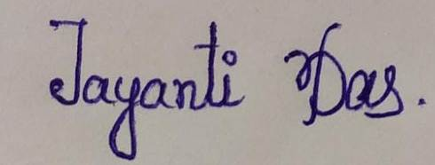**Place: MALDA**