CURRICULUM VITAE
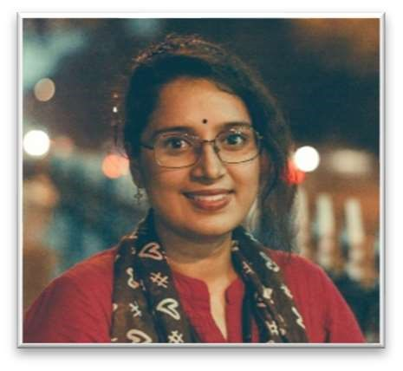
MONALISHABHATTACHARYYA
48
,ThakurparaRoad,

PO+PS–PurbaPutiary,RegentPark,
District–Kolkata

Pin–700093,WestBengal
E-Mail:
monalisha.riya.bhattacharyya@gmail.com

Mobile:7980368543,9038514079

PERSONAL PROFILE
- Date of Birth : 2nd November, 1997
- Gender : Female
- Marital Status : : Single/Unmarried
- Religion : Hinduism
- Nationality : Indian
- Languages Known : Bengali, Hindi, English and French
- Hobbies : Listening to music, Reading novels, etc.

ACADEMIC QUALIFICATIONS

Examination Passed | Year of Passing | Board/ Council/ University | Percentage | Division/ Class
ICSE (10th std.) | 2014 | ICSE | 89% | 1st
ISC (12th std.) | 2016 | ISC | 78% | 1st
B.A. (English Honours) | 2019 | Calcutta University | 49% | 2nd
M.A. (English) | 2021 | Calcutta University | 59.9% | 2nd
B.Ed. (English)(Appearing) | 2023 | WBUTTEPA | Appearing | Appearing

EXPERIENCE
- PGT English Teacher, BBITPS(CBSE): August, 2021 - Present
  - Secondary School English Teacher: August, 2021 – December, 2021
  - UKG Class Teacher and Primary School English Teacher: December, 2021 – Present

SKILLS & CERTIFICATIONS
- Basic computer knowledge/skills (Windows, MS-WORD, MS-EXCEL, INTERNET, E-MAIL).
- English For Career Development Course from Coursera under University of Pennsylvania.
- Communicative French from Ramkrishna Mission School of Languages.
- CBSE Training: Experiential Learning Course, Competency Based Education, Artificial Intelligence Appreciation

DECLARATION
I hereby declare that all the aforesaid statements are true to the best of my knowledge and belief.

Date: 11 February 2022
Place: Kolkata
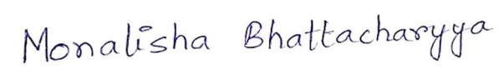
(MONALISHA BHATTACHARYYA)

