**BIO-DATA**

**NAME :**AMIT SARKAR

**FATHER’S NAME:**DILIP KUMAR SARKAR

**DATE OF BIRTH:04/04/199****4**

**ADDRESS:**

VILL.MAHESHPUR,BAGANPARA

PO.MOKDUMPUR

PS.ENGLISH BAZAR

DIST.MALDA

PIN-732103

WEST BENGAL

**CONTACT No.**7001070049

**E-MAIL:**amit.mayalove2013@gmail.com

**EDUCATIONAL QUALIFICATION:**

|  |  |  |  |  |
| --- | --- | --- | --- | --- |
| EXAM PASSED | NAME OF INSTITUTION | NAME OF BOARD | YEAR | MARKS(%) |
| MADHYAMIK | A.C.INSTITUTION | WBBSE | 2010 | 74.125 |
| HIGHER SECONDARY | MALDA ZILLA HIGH SCHOOL | WBCHSE | 2012 | 76.8 |
| GRADUATION(B.SC HONS.) | MALDA COLLEGE | UNIVERSITY OF GOUR BANGA | 2015 | 51.125 |
| B.ED | VIVEKANANDA TEACHERS TRAINING COLLEGE | UNIVERSITY OF GOUR BANGA | 2017 | 73.5 |

**OBJECTIVE:** To encourage creativity and higher-order thinking in a way that increases student performance.

**EXTRA QUALIFICAFION:**

1 Year diploma in computer application.

**HOBBIES:Cricket** And Traveling.

**LANGUAGE KNOWN:**BENGALI, ENGLISH, HINDI.

**NATIONLITY:** Indian

**RELIGION:** Hinduis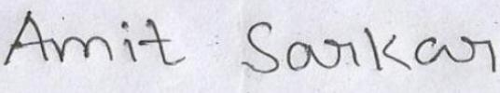m

**CASTE:** SC

**Date:……………… Signature**

**Place:……………...**