**RESUME**

**NAME :**PARUL CHOWDHURY

**FATHER’S NAME:**RANJIT CHOWDHURY

**DATE OF BIRTH:01/01/1995**

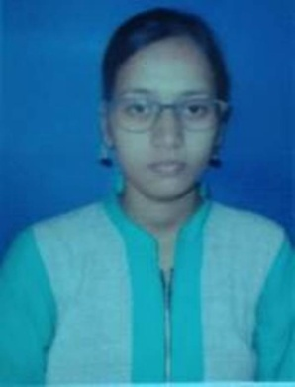

**ADDRESS:**

VILL.KALITALA 1ST LANE

PO.MOKDUMPUR

PS.ENGLISH BAZAR

DIST.MALDA

PIN-732101

WEST BENGAL

**CONTACT No.**8250148737

**E-MAIL:**parulchowdhury2015@gmail.com

**EDUCATIONAL QUALIFICATION:**

|  |  |  |  |  |
| --- | --- | --- | --- | --- |
| EXAM PASSED | NAME OF INSTITUTION | NAME OF BOARD | YEAR | MARKS(%) |
| MADHYAMIK | MALDA BARLOW GIRLS HIGH SCHOOL | WBBSE | 2010 | 67.5 |
| HIGHER SECONDARY | MALDA BARLOW GIRLS HIGH SCHOOL | WBCHSE | 2012 | 70 |
| B.A(ENGLISH HONS.) | MALDA COLLEGE | UNIVERSITY OF GOUR BANGA | 2015 | 46.5 |
| B.ED | VIVEKANANDA TEACHERS TRAINING COLLEGE | UNIVERSITY OF GOUR BANGA | 2017 | 74.85 |

**OBJECTIVE:** To encourage creativity and higher-order thinking in a way that increases student performance.

**EXTRA QUALIFICAFION:**

1 Year diploma in computer application.

**HOBBIES:** Traveling.

**LANGUAGE KNOWN:**BENGALI, ENGLISH, HINDI.

**NATIONLITY:** Indian

**RELIGION:** Hinduism

**CASTE:** SC

**Date:……………… Signature**

**Place:……………...**