**CURRICULAM VITAE**

NAME – SAURAV KUMAR SINGHA

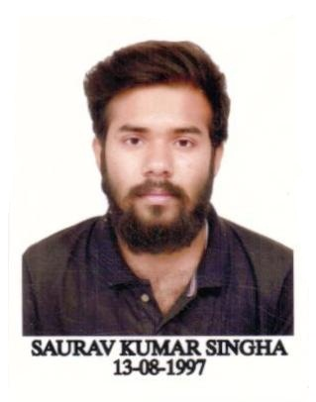

FATHER’S NAME – LATE RABINDRA KUMAR SINGHA

DATE OF BIRTH – 13/08/1997

RELIGION- HINDU

SEX- MALE

CATEGORY- GENERAL

ADDRESS – KRISHNAPALLY BAPUJI COLONY,MALDA

DIST - MALDA

PIN – 732101

**Mobile: +91-9064957336/8942977624**

**Email ID – sauravkrsingha97@gmail.com**

|  |
| --- |
| EDUCATIONAL QUALIFICATIONS: |

* **TECHINAL**

|  |  |  |  |  |
| --- | --- | --- | --- | --- |
| Examination | Board/Council | College | Year of passing | Grade point average |
| B.TECH  (ELECTRICAL ENGINEERING) | MAKAUT | IMPS COLLEGE OF ENGINEERING & TECHNOLOGY | 2020 | 7.0  (up to 6th semester ) |
| Diploma  (ELECTRICAL ENGINEERING) | WBSCTE | MALDA POLYTECHNIC MALDA | 2017 | 7.0 or 66.4 |

* **NON TECHNICAL**

|  |  |  |  |  |
| --- | --- | --- | --- | --- |
| Examination | Board/Council | School | Year of passing | Percentage of Marks |
| HIGHER  SECONDARY | WBCHSE | MALDA ZILLA SCHOOL | 2015 | **72%** |
| SECONDARY | WBBSE | MALDA ZILLA SCHOOL | 2013 | **78.5%** |

|  |
| --- |
|  |

* **TRANINGS UNDERTAKEN**

|  |  |  |
| --- | --- | --- |
| **NAME OF INSTITUTION** | **TOPIC** | **DURATION** |
| NTPC PVT LTD | VOCATIONAL TRAINING | 30 DAYS |

* **LANGUAGE KNOWN**

**1.** ENGLISH

**2.** HINDI

**3**. BENGALI

* **HOBBIES:**

**1.** CREATIVE WRITING

**2.** READING(NOVEL,POETRY,SHORT STORIES)

**3.** TRAVELLING

I hereby declare that all the above statements made are true and correct to the best of my belief and knowledge. In the event of any information being found false or incorrect at any point of time my candidature may be cancelled without any notice.

Saurav kr singha

* PLACE : MALDA signature

**(SAURAV KUMAR SINGHA)**

|  |  |  |
| --- | --- | --- |
|  |  |  |
|  |  |  |
|  |  |  |
|  |  |  |
|  |  |  |
|  |  |  |
|  |  |  |
|  |  |  |