**CURRICULUM VITAE**

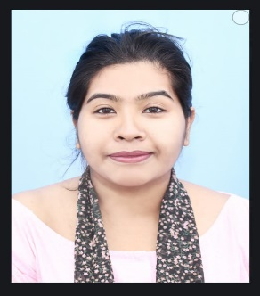 Maumita Debnath   
Date of Birth :17/04/1996  
Nationality: Indian  
Sex: Female   
Marital Status: Unmarried   
Father’s name: Rakhal Debnath   
Mother’s name: Pratima Debnath  
Contact No: 8918110536  
 8918790832  
 Email: maumitadebnath2023 @gmail.com   
  
**Educational Qualifications:**

|  |  |  |
| --- | --- | --- |
| **Qualification (S)** | **Name of the University/Institute** | **Year of Passing** |
| Mlib.sc | North Bengal University | 2022 |
| M.A(Rural Development) | North Bengal University | 2020 |
| Blib.sc | North Bengal University | 2018 |
| B.A (History) | Sital khuchi college | 2017 |

**Address for Communication:**

**Residence At-**

Vill- Nagar shova ganjPost-Bara gadai khoraPs: Sital khuchiDist.: coochbeharPin: 736172

Present address -

2 No. Govt. Colony

Near Ramkumar Balika Vidyalaya

P.o - Mokdumpur

P.s - English Bazar

Dist. - Malda, Pin - 732101, West Bengal

**WORKING EXPERIENCE:**   
1: Working as an intern at North Bengal University I was completed three month of internship programme at the university library in the session 2021-2022s a part of MLIS course.

2: Working with (IKONET RESEARCH & CONSULTANTS PRIVATE LIMITED) as a Quality Control associate in our various social research projects and associated in project specific assignments pertaining to data validation and data collection on CATI platform since 1st August 2020 to till now.

RESEARCH EXPERIENCE:

● Dissertation on: Youth Unemployment in coochbehar district (M.A).

● Dissertation on Application on social media on library services: A case study on North Bengal University (MLIS)

Participate in Seminar/ Conferences:

● Participated in National Seminar on Social implications of library & information science: Descriptive & prescriptive approaches on 14th -15th march, 2017 at North Bengal University.

● Participated in the 63rd All India Adult Education Conference jointly organized by Indian Adult Education association (IAFA) on 27rd - 29rd November ,2018 at North Bengal University.

Research Area/Area of Interest:

● College library/University Library (Digital library)

● Social research.

Courses under Taken:

• Information Technology Application.

• Office Management.

Disaster management.

Skills and Knowledge Areas:

● Work experience: Applications: Windows, 7 ,10 ,11 Basic computering Software: M.S. office, MS word, MS Excel, MS ppt.

● Survey Software : Survey to go.

Maumita Debnath