ABHINASH CHHETRI

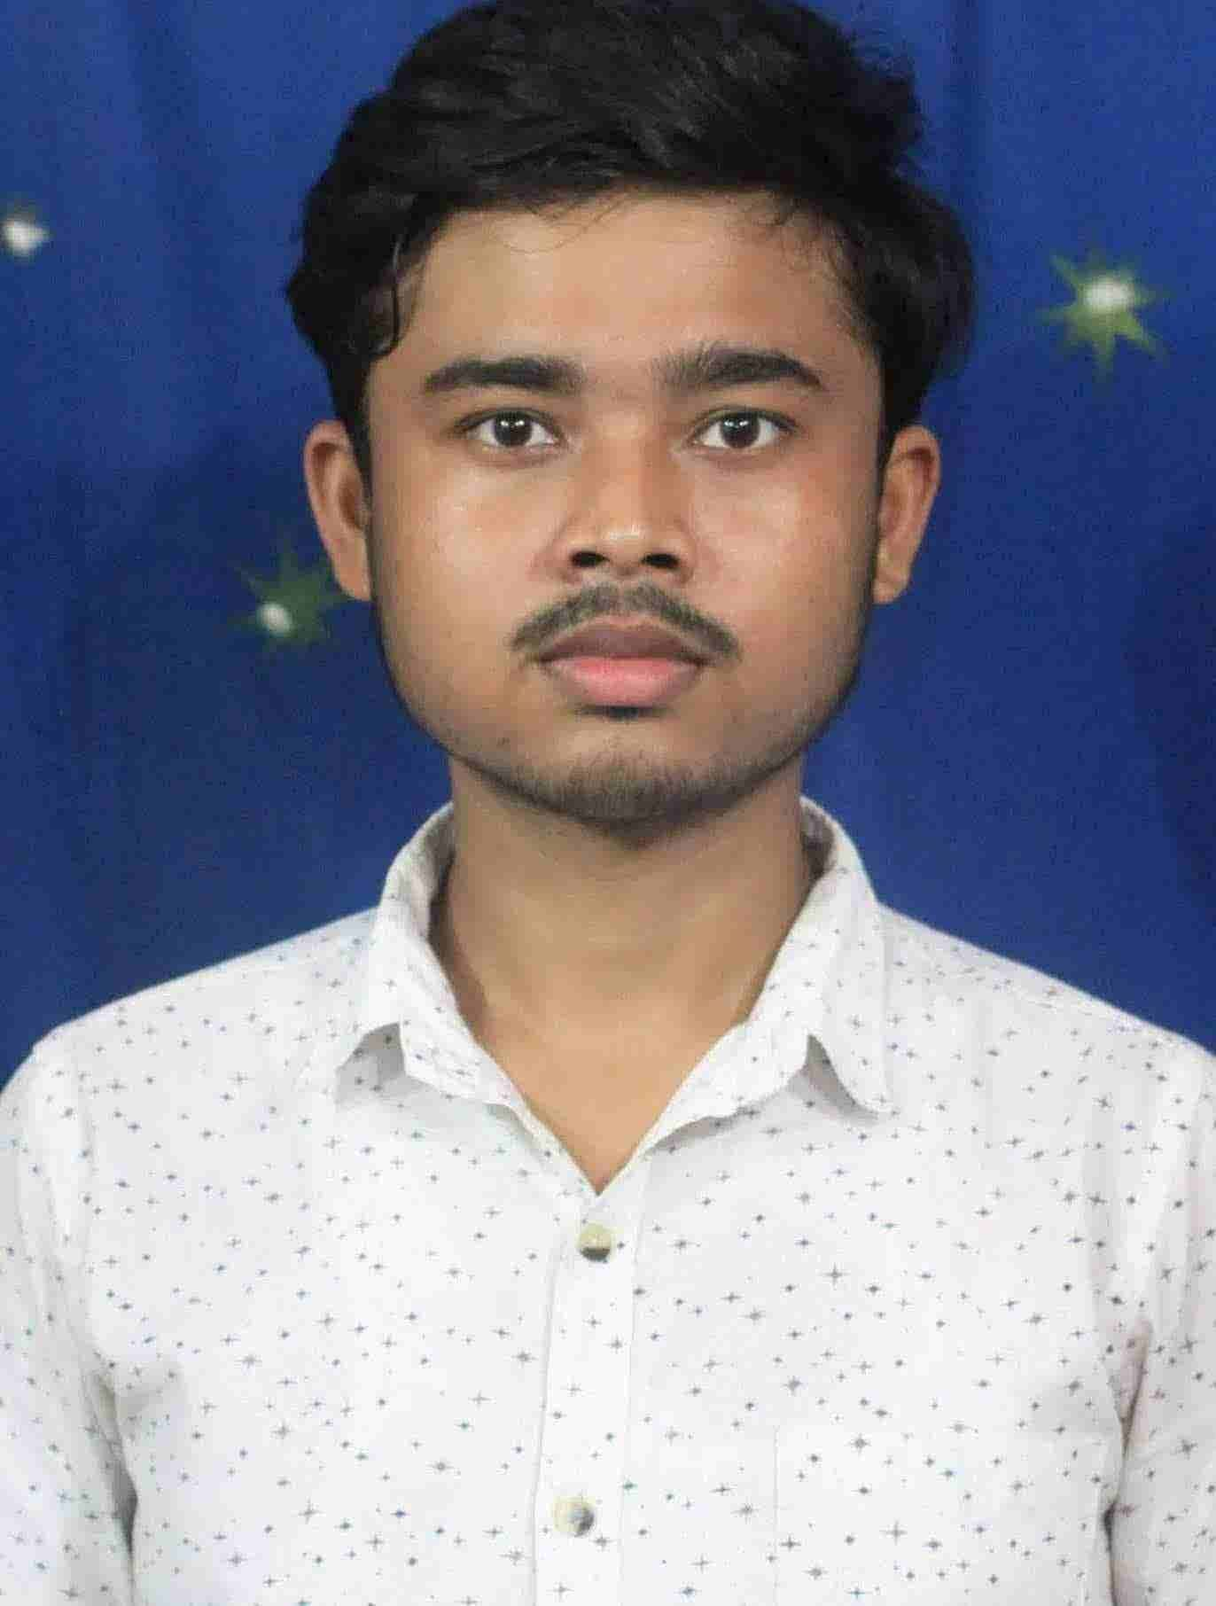

🏠 **Address Here : KRISHNAPALLY, BAPUJI COLONY,MALDA**

**🖁 Contact : 8345863619**

**Email : chhetriabhinash500@gmail.com**

***Personal Information***

Name : ABHINASH CHHETRI

Date of Birth : 26.10.2000

Marital status : Single

Religion : HINDU

Nationality : INDIAN

Mother Tongue : BENGALI

***Education Qualification***

**Education details…..**

**📚 Secondary Examination Pass With 33.57 % 2016**

**📚 Higher Secondary Examination Pass With 55.4% 2018**

**📚 Under Graduate Examination Pass With 53.70 % 2021**

***Computer Skills***

* **ITA**
* **Tally.ERP9**
* **GST**
* **RUNING SFX SOWFTWARE**

**Work Experience**

**To work for an organization which provides me the opportunity to improve my skills and knowledge to growth along with the organization objective? An enthusiastic fresher with highly motivated**.

**1 Year Experience as a Receptionist Baba Loknath Enterprise.**

***LANGUAGE***

* **BENGALI (SPEAK& WRITE),**
* **ENGLISH (WRITE),**
* **HINDI (SPEAK)**

**Pl PLACE:- MALDA**

SIGNATURE