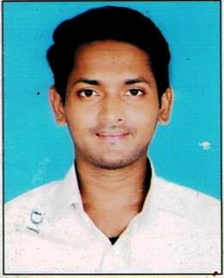
CURRICULUM VITAE

Name: - Devashish Sarkar
Mobile No: - 9910215155
Email :- devashishsarkar777 @gmail.com

Father Name: - Arun Sarkar
Date of Birth:- 10/04/1994
Sex :- Male
Nationality: - Indian
Religion:- Hindu
Marital Status: - Married
Caste :- General
Language Known: - Bengali, Hindi, English
Present & Permanent Address: - Vill- Kailashpur, Po- Mahadevpur , PS- Malda , Dst- Malda, Pin -732121.

Career Objective

To excel among the Professionals . Where I can utilize my skills with strong commitment and
dedication , for the progressive growth of the company.
Educational Qualification
Educational Level | Category | Name of the Board | Year of Passing | % of Marks
MA | Arts | IGNOU | 2018 | 54%
BA | Arts | Delhi University | 2016 | 55%
H.S. | Arts | CBSC | 2013 | 63%
Madhyamik | All | CBSC | 2011 | 62%

Experience
HDB Financial Services Representative Executive from 01Sep21 .
Computer Knowledge
I have completed Basic Computer Course and .

Date: Signature:

