**Debolina Dutta Chowdhury**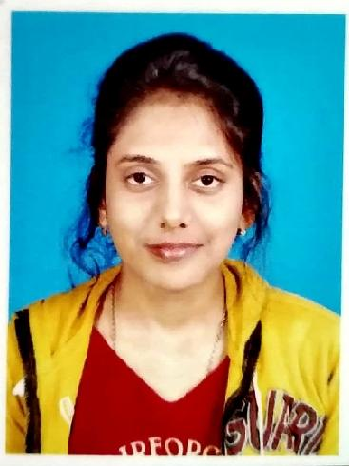

Gender: Female

Mobile no. 8391869835/ 9474638505

E-mail id- [tinniduttachowdhury@gmail.com](mailto:tinniduttachowdhury@gmail.com)

**Academic details**

|  |  |  |  |  |
| --- | --- | --- | --- | --- |
| Degree | Board/University | Year of passing | Subjects/Stream | Percentage |
| B.ed | WBUTTEPA | 2022 | Geography | 84.15% |
| M.sc | University of kalyani | 2020 | Geography | 74.81% |
| B.sc | University of kalyani | 2018 | Geography | 69.75% |
| Higher secondary | WBCHSE | 2015 | Arts | 89.2% |
| Matriculation | WBBSE | 2013 | All | 84.28% |

**Personal information**

**Father’s name:** Sushanta Dutta Chowdhury

**Mother’s name:** Nanda Dutta Chowdhury

**Date of birth-** 14/09/1996

**Address:** Rathbari Prantapalli Malda, Pin.732101, P.s- English bazar Dist.Malda

**Nationality:-** Indian

**Religion:** Hindu

**Caste:** General

**Marital status:** Unmarried

**Language known:** Bengali, English, Hindi

**Experience**: Total 1 year 1 months of teaching experience.

7 months of teaching experience in an English medium school in Islampur and 6 months of teaching experience in an English medium school in Simurali, Kalyani.

2 years experience as a subject matter expert in bartleby private limited.

**WB TET 2022 qualified**

**CTET paper 1 qualified in 2023.**