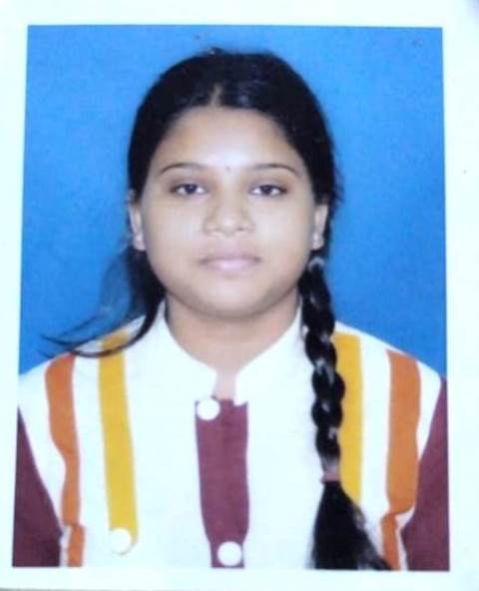
Resume

NAME : PAMPA SARDAR

FATHER’S NAME : MR. SANAT SARDAR

ADDRESS : VILL.- KOKILPUR, P.O.- ATPUKUR, P.S.- HAROA,
DIST.- 24 PGS (N), PIN- 743425.

DATE OF BIRTH : 11/02/1996

SEX : FEMALE

CAST : ST

RELIGION : HINDUISM

NATIONLITY : INDIAN

MARITAL STATUS : UNMARRIED

MOBILE NO. : +91 9123992424 / +91 8013992125

EMAIL ID. : pampasardar15@gmail.com

EDUCATION
QUALIFICATION :

EXAMINATION | BOARD/UNIVERSITY | YEAR OF PASSING | PERCENTAGE
MADHYAMIK | W.B.B.S.E | 2012 | 82%
H.S. (Science) | W.B.C.H.S.E | 2014 | 59%
B.SC | WBSU | 2018 | 50.25%

EXPERIENCE : CLASS 1 TO 5 STUDENT TEACHING
(3 YEAR'S).
COMPUTER
QUALIFICATION : BASIC, DIPLOMA IN FINANCIAL ACCOUNTING,
MS - OFFICE, INTERNET, TYPING.

LANGUAGE KNOWS : BENGALI, HINDI, ENGLISH.

DATE :

PLACE : HAROA
..…………….…………………….
PAMPA SARDAR

