**CURRICULUM VITAE** 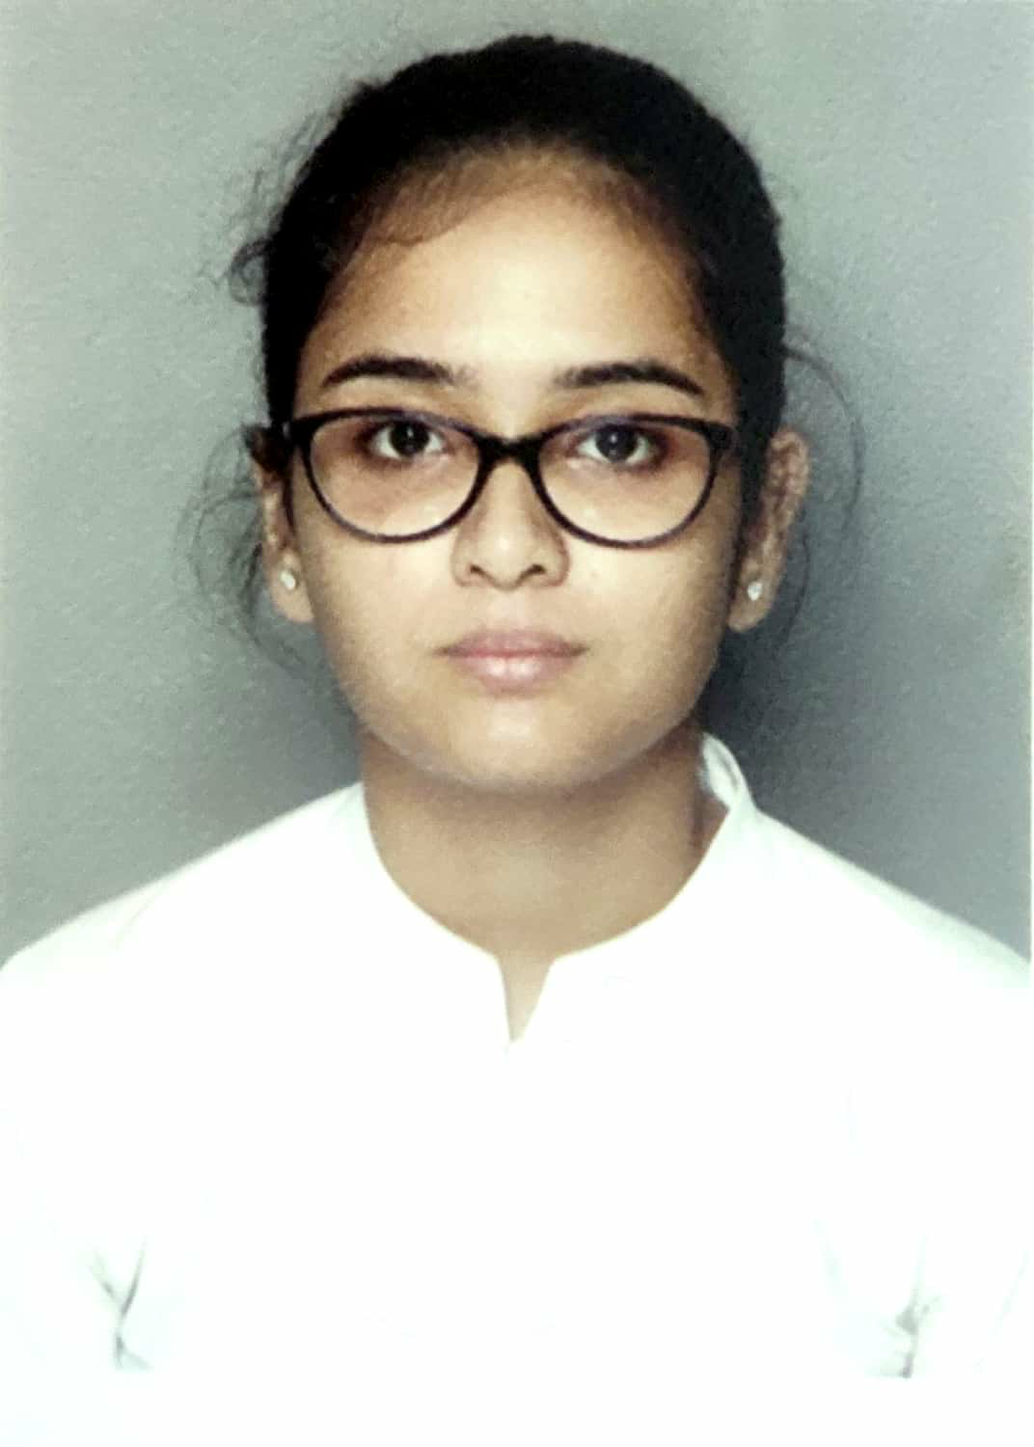

NAME: Aishwarya Mukherjee

ADDRESS: Debayatan Apartment 3rd floor **C2**, North Singatala, K.J.Sanyal Road, Malda -732101

CONTACT NUMBER: 8250104692/9563207338

DATE OF BIRTH: 05/04/1996

**CAREER OBJECTIVE:** To work in your esteemed organization wherein I can apply my technical and communication skills.

**WORKING EXPERIENCE:** I have been worked in **CALCUTTA PUBLIC SCHOOL BIDHAN PARK (KOLKATA)** since April 2019 to March 2021.

**EDUCATIONAL QUALIFICATION:**

1. Completed B.Ed course from **Jogendra Rajkrishna college of Teachers Education** under **THE WEST BENGAL UNIVERSITY OF TEACHERS’ TRAINING EDUCATION PLANNING AND ADMINISTRATION.**

**2.** Passed B.A(Hons) Part I, Part II & Part III in **Bengali** from **Bethune College** under **CALCUTTA UNIVERSITY** with a percentage of Part I 63, Part II 61, Part III 59

**3.** Passed Higher Secondary examination from **Barlow Girls' High School** with a percentage of 86 in 2015

**4**. Passed Madhyamik examination from **Barlow Girls' High School** with a percentage of 72 in 2013

**EXTRA CURRICULAR ACTIVITIES:**

**1**.Completed Rabindra sangeet 5th year in 2015 & Najrul Geeti 5th year in 2017 from "Bangiya Sangeet Parishad".

**2**.Best Talent award in Rabindra sangeet in 2015 with Gold Medal from BETHUNE COLLEGE.

**3**. Completed 5th year in Bharatnatyam with Gold Medal from "Nikhil Bharat Sangeet Samiti" in 2015

**4.** Completed 3rd year in Recitation in 2010 from Sarbabharatiya Sangeet O Sanskriti Parishad.

**CO CURRICULAR ACTIVITIES:**

1. Drawing

**PERSONAL DETAILS:**

Husband’s NAME: Animesh Banerjee

NATIONALITY: Indian

LANGUAGES KNOWN: Bengali, English, Hindi

COMPUTER PROFICIENCY: Basic CITA

**STATEMENT:**

The above information given are true to my knowledge and I am solely responsible for any kind of fallacy in it.

DATE: 26th of September, 2023

(Aishwarya Mukherjee)

PLACE: Malda