Anindya Mahata

Personal Details

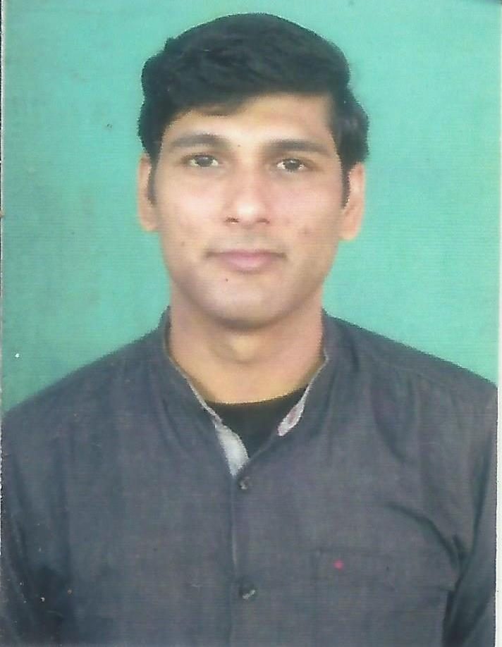
- Mobile : 7063856578
Affix Photo
- Email Id : anindyamahata007@gmail.com
- Date of Birth : 14 March 1985
- Gender : Male
- Nationality : Indian
- Religion : Hindu
- Languages Known : Bengali ,English & Hindi .
- Address : Air View Complex, Near ITI more ,
Malda, West Bengal,
Pin code: 732101.
Career Objective
To build a career in a teaching profession to help and motivate students in achieving their goals through my best knowledge and efforts.

Academic Qualification

B.Ed. (Bachelor of Education) Gour Banga University 2011

Post Graduation(M.C.A) SRM University 2009
Graduation(B.C.A) North Bengal University 2006
Higher Secondary(10+2) W.B.C.H.S.E 2003
Madhyamik(Class-10) W.B.B.S.E 2001

Professional Skills
- Have excellent communication & instructional skills.
- Ability to teach in English,Bengali & Hindi.
- Working knowledge with computers & internet.
- Can plan and execute in class and outdoor educational activities & events.

Experience
- Worked in Kendriya Vidyalaya Malda as a Contructual Teacher.
- Worked in State Govt. Vocational Training Institute(Bangitola High School).

Hobbies
- Playing Cricket,Badminton and Chess
- Drawing

Declaration: I hereby declare that all the above information is true to the best of my knowledge.
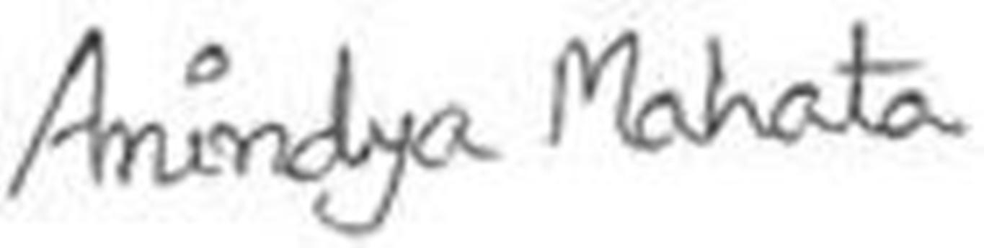
Place:
Date: Signature

