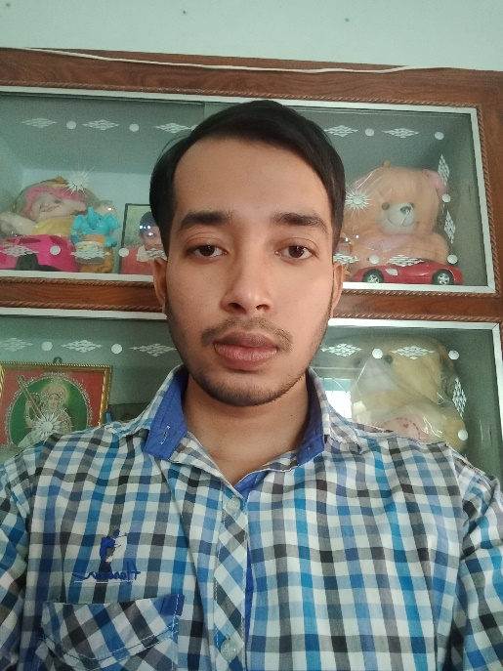 |  | Name: - DIBAKAR PODDAR.  Contact Number- 8509442400  WhatsApp- 8509442400  Mail Id: poddardibakar27@gmail.com  C/o- MR. PROSAD PODDAR.  ADDRESS:-  Village: Puratan Mahespur  Post Office: Mokdumpur  Police Station: English Bazar  District: Malda  PIN- 732103

Educational Background: -
Name of the Institute | Name of the Board | Name of the Examination with passing years | Percentages (%)
A.C.Institution | WBBSE | Secondary Examination (2013) | 74.42%
A.C.Institution | WBBHSE | Higher Secondary Education (2015) | 79.4%
Gour Mahavidyalaya | UGB | Graduation in English (HONS.) | 46.42%

Other Qualifications: -
- I had completed my D.El.Ed from Anadi Charan Memorial Teachers’ Training College, Birhampur, Malda.
- I am pursuing in the course of Advanced Diploma In Information Technology Application from Malda Sadar Youth Computer Training Center.

ACKNOWLEDGEMENTS: -
I would like to express that, all the above information which I gave is accurate. Please, kindly read all the documents carefully and let me know about your precious decision. I will eagerly wait for your next call letter.

