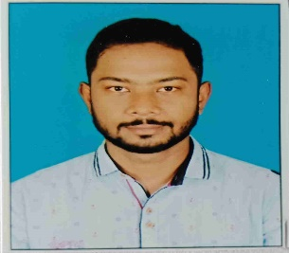

|  |  |
| --- | --- |
| **SUMON ROY** | **Address**:Narayanpur,Narendranagar.  PO: R-Gopalpur  Kolkata – 700136  Mobile no:– **9123923243**  Email:- **roy.sumon8981@gmail.com** |

|  |
| --- |
| **Objectives:** |
| My aim is to work innovatively for the enhancement and betterment of education. I aspire to work for an institution which offers career growth and chances to learn and improve my knowledge. |
|  |

**Teaching Experience:**

**1. Eight years’ experienced** as private tutor from class VIII-XII **Mathematics** (C.B.S.E, I.C.S.E, W.B)

**2. Three years’ experienced** as **Mathematics**  faculty in **Indian Force Academy** (**Competetive exam** institute)

**3. Two years’ experienced** as **PGT Mathematics** at **National English School.**

|  |
| --- |
| **B.ED (2021-2023)** |
| Degree : **B.Ed**  College(University) : **Institute of Human Excellence**  University : **West Bengal University of Teachers' Training, Education Planning and Administration** |
| Percentage **: 84.15** |

|  |
| --- |
| **Masters Educational Details (2019-2021)** |
| Degree : **MSc.** **Mathematics**  College(University) :**The University of Burdwan**  Subject : **Mathematics**  Percentage : **76.9** |

# Graduation Educational Details (2013-2017)

Degree : **BSc.(Math Honors)**

University : **West Bengal State University**

Subject :  **Mathematics (Honors)**

**Pass Subject – Physics, Computer Science**

Percentage : **49.75**

Page 1

|  |
| --- |
| **10th  & 12th Educational Details :** |
| **Examination Board/Council Name of School Year of Percentage**  **Passing**    Secondary W.B.B.S.E Bishnupur Sir Ramesh  Institution 2010 66.8  High Secondary W.B.C.H.S.E Chittaranjan Colony 2012 60  HIndu Vidyapith |
| **Personal Details** |
| Date of Birth : 11th Sep ,1993  Permanent Address : Narayanpur,Narendranagar,Natunpally.PO:R-gopalpur.Kolkata:700136  Nationality : Indian  Marital Status : Unmarried  Sex : Male  Language Skills : English, Hindi and Bengali  Phone No. : 9123923243 |

I am declaring that all the above information is true to the best of my knowledge and belief.

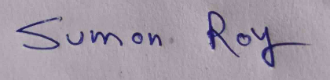

Date : 14/12/2023

Place : Kolkata --------------------------------------

(Signature)

Page 2