**BIO DATA**

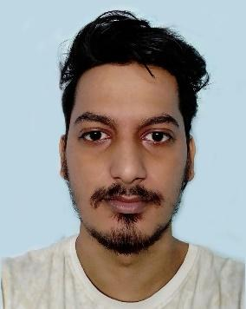

Name : Biswajit Rishi

Address : Binoy Sarkar Road, Malda

Mobile :7001683393

Email id :biswajitrishi34@gmail.com

Father’s Name :Paltu Rishi

Gender : Male

Date of Birth : 01/04/1995

Marital Status : Unmarried

Religion : Hindu

Languages Known : Bengali, Hindi, and English

Others Qualification : Computer application and Tally

**Qualification**

|  |  |  |  |
| --- | --- | --- | --- |
|  | Board | Year of Passing | Marks Percentage |
| Madhyamik | WBBSE | 2010 | 55 % |
| H.S | WBCHSE | 2012 | 54% |
| Graduation | UGB | 2015 | 45% |

I have An Art Centre Which I operate from last 10 Year , you can scan the below QR

code to visit my page. There you can see some of my student’s work, thank you.



Place : Malda Date : 22/08/2023