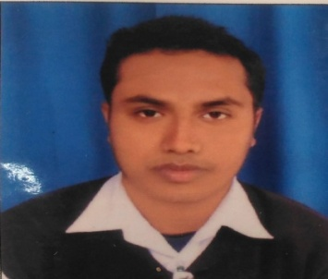

CURRICULUM VITAE

DEBDAS DUTTA

“Young, energetic, qualified, committed to any assigned work”

CAREER OBJECTIVE:-

I would like to be associated with an organization to undertake challenging and responsible job where my education, skills, ability will be applicable and keep knowledge updated with the new trends.

WORK EXPERIENCE:-

- 1 Year experience of George School of Competitive Exams, Islampur Branch
as a Centre in charge.

- 4 Years experience in PATHFINDER EDUCATIONAL CENTRE as a Centre–in-charge in Raiganj branch.

EDUCATIONAL QUALIFICATION:-

NAME OF EXAM | BOARD/UNIVERSITY | YEAROF PASSING | PERCENTAGE
MADHYAMIK | W.B.B.S.E | 2008 | 80.38
HIGHER SECONDARY | W.B.C.H.S.E | 2010 | 71.60
B.A(HONS) | U.G.B | 2015 | 54.25
B.ED | WBUTTEPA | 2020 | 85.35

LANGUAGE KNOWN:-

NAME | READ | WRITE | SPEEK
BENGALI | YES | YES | YES
ENGLISH | YES | YES | YES
HINDI | YES | NO | YES
.
EXTRA QUALIFICATION:-

- Basic knowledge in Computer Application,

- Diploma in Computer Application.

HOBBIES:-

- Listening to music.
- Writing and Acting.

PERSONAL DETAIL:-

Date of Birth :- :05/06/1991
Nationality: - : Indian.
Religion: - : Hindu.
Gender: - : Male.
Category: - : General.
Marital Status: - : Unmarried
Mob No: - : 9614070303
Mail ID: - :deb.debdas2@gmail.com

PRESENT ADDRESS :-

Father Name: - : Gobinda Chandra Dutta
Vill+Po: - :Moyna
Po: - :Gazole
Dist: - :Malda
Pin No: - :732124

DECLARATION:-

I am quite confidence about myself and lead my team from front. I give my almost to my organization and always I think beyond the possible and I like to go for extra time.I understand that in the event of any information being found untrue or incorrect at any stage / in the event any circumstances which may impair my fitness for employment in organization / I do not satisfy any of the eligibility criteria stipulated, my candidature is liable to be cancelled.I hereby declare that all statements made in this application are true, complete and correct to the best of my knowledge and belief.

DATE:-…………………………….

PLACE:-…………………………..

Signature

