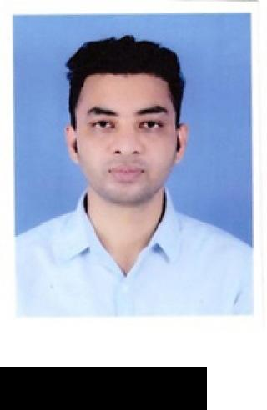

**OBJECTIVE**



**EDUCATION**



**STRENGTH**



**IT SKILL**



**EXPERIENCE**



**PERSONAL INFORMATION**

**TANMAY MANDAL**



**Post applied for Assistant Teacher.**

KRISHNAPALLY,BANDH ROAD **E-mail:** tanmaymandal444@gmail.com

P.S:- ENGLISH BAZAR, **Phone:** 9832089663

P.O+DIST:- MALDA

WEST BENGAL, PIN 732101

Looking for an opportunity to secure the position of a Teacher where I can employ all my skills for the benefit of the school. Well skilled, educated followed by internship like to achieve good progress in my career through all my best subject knowledge and great teaching efforts.

|  |  |  |
| --- | --- | --- |
| **UNIVERSITY/INSTITUTE** | **YEAR/SESSION** | **PERCENTAGE** |
| **B.ED**  MAHARSHI DAYANAND UNIVERSITY | 2013-2014 | 66.70 |
| **POST GRADUATION(GEOGRAPHY)**  GURU GHASIDAS VISHWAVIDYALAYA | 2010-2012 | 58.60 |
| **GRADUATION (GEOGRAPHY)**  UNIVERSITY OF KALYANI | 2007-2010 | 52.00 |
| **12th**  KENDRIYA VIDYALAYA MALDA | 2007 | 68.60 |
| **10th**  KENDRIYA VIDYALAYA MALDA | 2005 | 45.60 |

Enthusiastic and hardworking.



Possess Positive attitude.



Responsible towards work.



Self-motivated and directed.



MS-OFFICE SUITE (Excel, Word, Power Point,)



INTERNET SURFING



Kendriya Vidyalaya B.S.F Aradhpur, Malda (1st April 2017 to 31st March 2018).

Sister Nivedita Public School, Malda. (1st April 2018 to 28th March 2019).

Tarbiyah Cambridge International School, Malda.(1st April 2021 to 26 March 2022).

North Point English Academy, Malda.(1st April 2022 to 26 March 2023).

North Point Public School, Malda.(27th March 2023 to 5th August 2023).

Presently working in St. Mary's School, Malda.

**FATHER'S NAME** - HARENDRA NATH MANDAL

**DATE OF BIRTH** - 10/02/1989

**LANGUAGE KNOWN** - HINDI,ENGLISH,BENGALI.