**CURRICULAM VITAE**

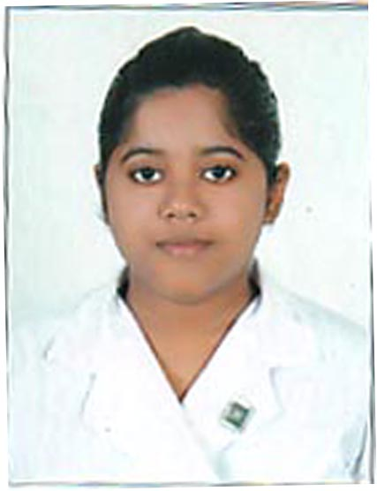

The following particulars are furnished in favor of my candidature:

**NAME :** SHIRSA DAS (GHOSH)

**FATHER’S NAME :** Mr. SAILENDRA NATH DAS

**MOTHER’S NAME :** Mrs. RAKHI DAS

**ADDRESS :** D-33 , SARADA PARK ,BIREN ROY ROAD (WEST),

P.O – SHIBRAMPUR, P.S.- MAHESHTALA,

KOLKATA – 700141

**TELEPHONE NUMBER :** 9875670299

**E-MAIL ID :** [shirsadas.2013@gmail.com](mailto:shirsadas.2013@gmail.com)

**PERSONAL INFORMATION :**

**DATE OF BIRTH :** 17 – 10 – 1994

DD – MM – YYYY

**SEX :** FEMALE

**MARITAL STATUS :** MARRIED

**NATIONALITY :** INDIAN

**LANGUAGES KNOWN:**

|  |  |  |  |
| --- | --- | --- | --- |
|  | **ENGLISH** | **HINDI** | **BENGALI** |
| **SPEAK** | YES | YES | YES |
| **WRITE** | YES | YES | YES |
| **UNDERSTAND** | YES | YES | YES |

**EDUCATIONAL QUALIFICATIONS**

I have graduated in Bachelor of Arts (B.A) English Honours degree course of Calcutta University, from Shri Shikshayatan College, 11 Lord Sinha Road, Kolkata – 700071. I have completed my Masters(M.A) in English from Shri Shikshayatan College (C.U).

|  |  |  |  |  |  |  |  |  |  |  |  |  |  |
| --- | --- | --- | --- | --- | --- | --- | --- | --- | --- | --- | --- | --- | --- |
| **SERIAL**  **NUMBER** | **YEAR** | | **EXAMINATION** | | **CLASS** | | **BOARD / UNIVERSITY** | | **SCHOOL/ COLLEGE** | | **PERCENTAGE OF MARKS** | | |
| 1 | 2011 | | All India Secondary School Certificate Examination | | 10 | | Central Board of Secondary Education, Delhi | | G.S.S Girls’ School | | 80% | | |
| 2 | 2013 | | All India Senior School Certificate Examination | | 12 | | Central Board of Secondary Education, Delhi | | Ashok Hall Girls’ Higher Secondary School | | 89.25% | | |
| 3 | 2014 | | B.A. Part – 1 (Three Years Honours ) Examination | | 1st year | | University of Calcutta | | Shri Shikshayatan College | | 55% | | |
| 4 | 2015 | | B.A. Part – 2 (Three Years Honours ) Examination | | 2nd year | | University of Calcutta | | Shri Shikshayatan College | | 56% | | |
| 5 | 2016 | | B.A. PART-3 (THREE YEARS HONOURS) EXAMINATION | | 3RD YEAR | | UNIVERSITY OF CALCUTTA | | SHRI SHIKSHAYATAN COLLEGE | | 49.25% | | |
| 6 | | 2017 | | M.A. PART-1 | | 1ST YEAR | | UNIVERSITY OF CALCUTTA | | SHRI SHIKSHAYATAN COLLEGE | | 52% |
| 7 | | 2018 | | M.A.PART-2 | | 2ND YEAR | | UNIVERSITY OF CALCUTTA | | SHRI SHIKSHAYATAN COLLEGE | | 56% |
| 8 | | 2019 | | B.ED | | 4TH  SEMESTER (FINAL YEAR) | | UNIVERSITY  OF CALCUTTA | | SHRI  SHIKSHAYATAN  COLLEGE | | 84.9%( till 3rd semester) |

**JOB EXPERIENCE**

* Worked as a Class Teacher and English Teacher in B.D MEMORIAL INTERNATIONAL SCHOOL (VIJAYGARH BRANCH) from 27.8.2018 to 5.6.2019.

**ACHIVEMENTS**

* Senior Diploma in Fine Arts in the year 2001 and 2002.
* Secured First Division in Bharat Natyam Dance in the year 2004 and 2005.
* Secured First Division in Painting in the year 2004.
* Secured 10th position in Art Exhibition in the year 2003.
* Participated in Hyundai Sketch The I Competition.
* Obtained a certificate in Interior Designing from Birla Institute of Liberal Arts and Management Science.
* Participated in Poster Making (Vidyasagar Diwas) in the 2014.
* Participated in the Seminar held at Shri Shikshayatan College in the year 2015.
* Secured 57.33% in Sociology and 58% in Political Science from University of Calcutta in the year 2015, studied throughout class 11 and 12.

**EXTRA – CURRICULAR ACTIVITIES**

* Painting at free time.
* Reading story books.
* Swimming at leisure.

---------------------------------------------------------------------------------------------------------