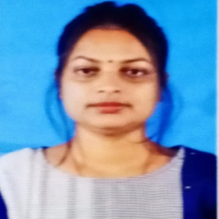NAMITA SAMAJDAR

**Habibpur,Malda,732122**

[**namitasamajdar755@gmail.com**](mailto:namitasamajdar755@gmail.com) **8918317824**

***CAREER OBJECT***

***EXPERIENCE QUALIFICATION***

***PERSONAL SKILLS***

***PERSONAL PROFILE***

***EXTRA QUALIFICATION***

**to be a part of progressive growth oriented organization through application of my skill knowledge**

1 YEAR ENGLISH TEACHERS EXPERIENCE IN O2 PUBLIC SCHOOL.

***W.B.B.S.E(BULBULICHANDIR.N.ROYGIRLSHIGHSCHOOL)***

**Madhyamikpassed 2015 — 460(65%)**

***W.B.C.H.S.E.(AIHOHIGHSCHOOL)***

**HS Passed**

**2017—415(83%)**

***UNIVERSITYOFGOURBANGA(MALDAWOMEN'SCOLLEGE)***

**Graduation 2021 —**

**English Honours 550(68%)**

***WBUTTEPA***

**B.Ed**

**2023—1762(88.1%)**

 **Innovationandcreativethinking Leadership thinking**

**ComprehensionProblemsolvingability Hard work**

**Analyticalandinvestigatethinking Content writing**

**Copywriting**

Father's Name - Subhash SamajdarMother'sName-AnjaliSamajdar Date Of Birth - 26/08/1997

Permanentaddress-

Vill-Habibpur,P.O-Habibpur,P.S-Habibpur,Dist-Malda,Pin-732122

Gender-Female

Marital status - Unmarried Relegian - Hinduism

Nationality-Indian

AdvanceDiploma(2 year)

***Language* Bengali,English,Hindi**

***Declaration***

**Idoherebydeclarethattheparticularofinformationandfactstatedhereinaboveare true,correctandcompletetothebestofthemyknowledgeandbelief**

**Signature:**

**NamitaSamajdar**