RESUME

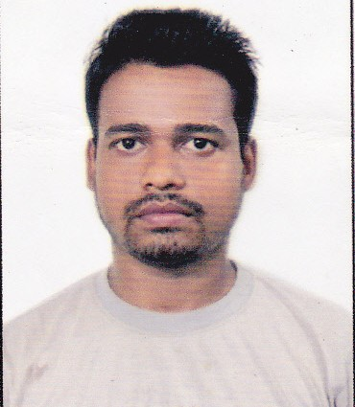
Name: Abu Samet Barbhuiya

PERMANENT ADDRESS:-
BORKHOLA- PART 1
Dist- Cachar (Assam)
Pin- 788110.

CONTACT NUMBER- 8638871441

E-mail:-salimiittm @gmail.com

Career Objective
To solve problems in a creative and effective manner, and to open up new avenues of solutions while maintaining the standards set by the organization.

Educational Qualification

COURSE | INSTITUTE | BOARD OF EXAMINATION | YEAR | RESULT
Pgdm in (travel &tourism) | INDIAN INSTITUTE OF TOURISM AND TRAVEL MANAGEMENT-Bhubaneswar | autonomous | 2013-14 | 59.6%
Bachelor of travel & tourism management | NSHM-BUSINESS SCHOOL | West Bengal university of technology(wbut) | 2011 | 62%
12th  (ARTS) | GYAN GANGA VIDYAPEETH | CBSE | 2008 | 72%
10TH | K.V. NO.2 ITANAGAR | CBSE | 2006 | 59.8%

Present Qualification

P

PGDM-TT, Post graduate diploma in Management, equivalent to MBA
(in tourism & travel) with specializations in tour operation &marketing , under Ministry of tourism, Govt. of India, Bhubaneswar

Area of Interest

- Interested in the field of Destination Marketing, Product Marketing, Tour Operation.

Work experience/Internship

- Worked as SR. SALES EXECUTIVE in yatra.com, KOLKATA (from DEC 2013-31st DEC 2015).
- Worked in "Pushpak Travels "-guwahati as a Sr. Sales Executive (from January 2016- October 2017)
- Worked as English Teacher in "Universal Academy "-Kalain. (from Dec 2017- 19th April 2018)
- Worked in "Nehru Higher Secondary School", Pailapool as Tourism and Hospitality Trainer( 20th April 2018 - 31st July 2022).
- Currently working in "TH Gunumani Academy" as Asst Teacher (1st September 2022- till date).

Personal details

Father’s Name : K.R.Barbhuiya
Mother’s Name : Ayesha Barbhuiya
Date of Birth : 29.03.1990
Sex : Male
Languages : English, Hindi, Assamese, Bangla
Nationality : Indian

Declaration

- I hereby declare that the above stated information is true to the best of my knowledge and belief.

PLACE: - Silchar
Name: - Abu Samet Barbhuiya

