1. ***CURRICULUM VITAE***

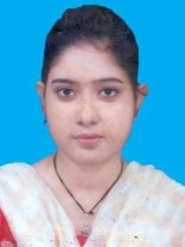**EKTA SARKAR**

D/O – BAPPADITYA SARKAR

Mob- 6297902235

Email Id –ektasarkarsen@gmail.com

**___________________________________________________________________**

**Objective**:

To contribute my level best to myself whatever through a part of a team or individual to achieve the peak of the goal of the organization. I work

***Academic Qualification***:

|  |  |  |  |  |  |
| --- | --- | --- | --- | --- | --- |
| Name of The Examination | Name of the Board | Year of Passing | Full  Marks | Total  Marks  Obtained | % of Marks |
| M.P | W.B.B.S.E | 2011 | 800 | 519 | 64.87% |
| H.S | W.B.C.H.S.E | 2013 | 500 | 275 | 55% |
| B.SC | U.G.B | 2017 | 800 | 401 | 50% |
| M.SC | U.G.B | 2019 | 1000 | 625 | 62.5% |

|  |  |  |  |  |  |
| --- | --- | --- | --- | --- | --- |
| B. Ed | WBUTTEPA | 2021 | 2000 | 1778 | 88.9% |

***Personal Details***:

Date of Birth: 15.02.1995

Gender:Female

Nationality: Indian

Languages Know: Bengali, Hindi, English

Religion :Hindu

Permanent Address: Vill: Madhabnagar , PO: English Bazar PS : Malda

Dist :Malda, Pin: 732101

***DECLARATION***:

I hereby declare that the above furnished details are true and correct to the best of my knowledge and belief.

Date:_________ __________________

Place:_________ Signature