**BIODATA**

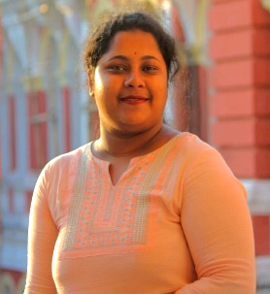NAME :- SUSMITA SUTRADHAR

FATHER'S NAME :- SHYAMAL SUTRADHAR

MOTHER’S NAME :- ARATI SUTRADHAR

ADDRESS :- CHHATGURIAHATI, NEW TOWN, DINHATA ROAD, P.O + DIST. – COOCHBEHAR

P.S – KOTWALI , PIN – 736101

QUALIFICATION

|  |  |  |  |  |  |
| --- | --- | --- | --- | --- | --- |
| **NAME OF EXAM** | **BOARD** | **YEAR OF PASSING** | **DIVISION** | **MARKS OBTAINED** | **PERCENTAGE OF MARK OBTAINED** |
| MADHYAMIK | WBBSE | 2014 | 2ND DIV. | 327 | 46.7% |
| HIGHER SECONDARY | WBCHSE | 2016 | 1ST DIV. | 315 | 63% |
| GRADUATION (BENGALI HONORS) | NSOU | 2021 | 1ST DIV. | 584 | 73% |
| BLIS (BACHELOR OF LIBRARY & INFORMATION SCIENCE) | CBPBU | 2023 1ST DIV | | 552 | 69% |

**EXTRA QUALIFICATION – DIPLOMA IN ADITA (COMPUTER )**

GENDER – FEMALE

RELIGION – HINDUISM

DATE OF BIRTH - 09.10.1997 PHONE NO. – 9382460979

CASTE - OBC- B

LANGUAGE – BENGALI, HINDI, ENGLISH EMAIL – [Susmitadhar03@gmail.com](mailto:Susmitadhar03@gmail.com)