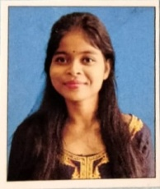

VILL-CHOWDHURY GACHH

P.O- CHOPRA

P.S- CHOPRA

DIST- NORTH DINAJPUR

PIN- 733207

CURRICULAM VITAE

**PRIYA HEMBROM**

**OBJECTIVE:**

Aspire for a career which provides me with continuous learning opportunities through exposure to different of situation and environment.

PERSONAL DETAILS

FATHER’S NAME : SUSHIL HEMBROM

DATE OF BIRTH : 15-07-2000

PHONE NO : 6294253940

E-MAIL : priyahembrom7@gmail.com

NATIONALITY : INDIAN

RELIGION : CHRISTIAN

LANGUAGES KNOWN : BENGALI,HINDI,ENGLISH

HOBBIES : READING, DANCING

EDUCATIONAL QUALIFICATION

|  |  |  |  |  |
| --- | --- | --- | --- | --- |
| Examination  Passed | Year of Passing | Name of Board  / University | % of Marks | Divn./Grade |
| MADHYAMIK | 2016 | W.B.B.S.E | 59% | A |
| H.S | 2018 | W.B.C.H.S.E | 88% | A+ |
| GRADUATION | 2021 | NORTH BENGAL | 69% | A |
| B.ED | 2023 | BABA SAHEB AMBEDKAR EDUCATION UNIVERSITY | RUNNING | RUNNING |

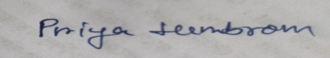DECLARATION : I do hereby declare that all the information are true to the best of my knowledge and belief.

Place:- CHOPRA

Date :- Signature of the Candidate