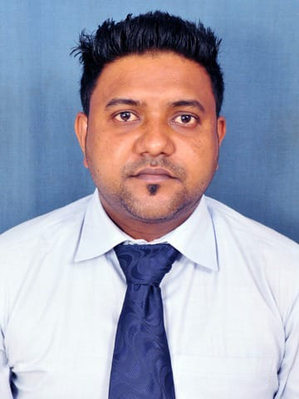
HADLEE VALENTINE JAMES

PROFESSIONAL SUMMARY

Experienced and driven as an Office Administrative with experience of advance diploma in computer applications. Proficient in Microsoft Office (Word, Excel, PowerPoint) and managing, arranging, and coordinating executive calendars, travel, contacts, conference bridges, appointments, and events. Thrive within detail-oriented, deadline-driven environments. Regularly acknowledged by leadership for timeliness and attention to detail.

WORK EXPERIENCE

14/07/2022 – 29/09/2022

- Worked as an Office Assistant in Father Leblond School, Siliguri.

06/08/2018 to 30/06/2021

- Worked as an Office Administrative at Universal Petro Chemicals Limited from 26.08.2018 to 30.06.2021

- Proficient in Microsoft Office (Word, Excel, PowerPoint)

- Managing, arranging, and coordinating executive calendars, travel, contacts.

- Handling incoming calls and other communications.

- Managing filing system.

- Updating paperwork, maintaining documents and word Processing.

- Helping organize and maintain office common areas.

- Organizing travel by booking accommodations and reservation needs as required.

  - 1 year worked as an office assistant in NEOME Animation Institute.

  - 6 months in St. Thomas nursery school as an office Administrative.
EDUCATION

- Bachelor Degree In English Honours , Indira Gandhi National Open University
- Class 12, National Institute of Open Schooling
- Class 10, National Institute of Open Schooling

ADDITIONAL COURSE

- Advance Diploma in Computer Application
- Pursuing Advance Diploma in Financial Accounting System

ADDITIONAL SKILLS

Microsoft Office package: Microsoft Word, Excel, Power Point
Adobe Photoshop.
PERSONAL DETAILS

Date of Birth : 21st December 1988

Father's Name : Late Desmond James

Religion : Christian (Roman Catholic)

Mother Tongue : English

Nationality : Indian

LANGUAGES KNOWN

- English

- Hindi

- Bengali

CONTACT

Permanent Address:
Holding No 168\4 Ward No 29 Sonamukhi,
Jholi ,Kharagpur.
Pin:721306

Present Address:
Maya Apartment
Hathkola More
Barasat, Kolkata
Pin: 700126

Phone No:
9609084081

Email:
hadlee.james@gmail.com

