**Curriculum Vitae** 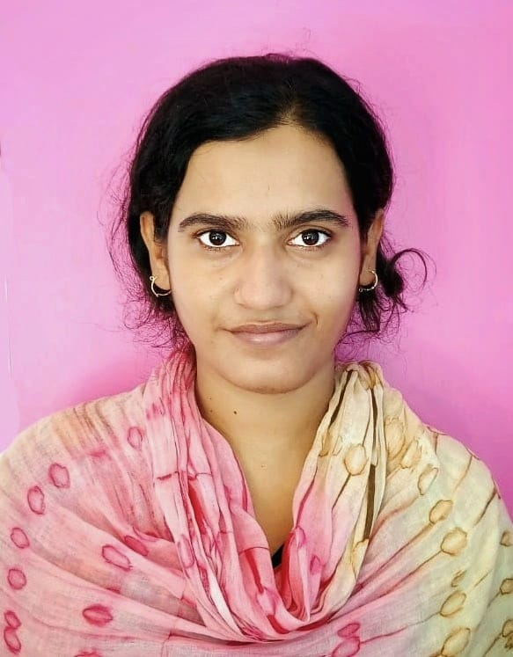

**NAME : RESHMI MANDAL**

**FATHER'S NAME :** L'T. MATIUR MANDAL

**MOTHER'S NAME :** JAHANARA BEWA

**DATE OF BIRTH :** 15/01/1994

**SEX :** FEMALE

**RELIGION :** ISLAM

**CASTE :** GENERAL

**MARITAL STATUS :** UNMARRIED

**NATIONALITY :** INDIAN

**PERMANENT ADDRESS :** VILL:- HINDU PARA, BARA SUJAPUR,

P.O:- SUJAPUR, P.S:- KALIACHAK, DIST:- MALDA,

PIN:- 732206, STATE:- WEST BENGAL

**CONTACT NUMBER :** +91-8617896103 / 8370985755

**E-mail ID :** reshmini075@gmail.com

**LANGUAGES KNOWN :** ENGLISH, BENGALI & HINDI (Can read, write,

& speak fluently)

**EDUCATIONAL QUALIFICATION :**

| **Exam. Passed** | **Board** | **Passing**  **Year** | **Total Marks** | **Marks Obtained** | **Percentage**  **(%)** |
| --- | --- | --- | --- | --- | --- |
| Madhyamik | W.B.B.S.E | 2009 | 800 | 617 | 77.12 |
| H.S. (Bio Science) | W.B.C.H.S.E | 2011 | 500 | 329 | 65.80 |
| B.A. English Honours | I.G.N.O.U. | 2019 | 1200 | 696 | 58.00 |
| B.Ed (English) | WBUTTEPA | 2022 | 2000 | 1898 | 94.90(10 CGPA) |
| M.A.( English) | I.G.N.O.U. | 2023 | 800 | 514 | 64.25 |

**CAREER OBJECTIVE :** Involved with teaching for more than 5 yrs and preparing for various

competitive exams.

Would like a challenging yet fulfilling post regarding to education.

**SKILLS :** Enthusiastic, Energetic, Adaptable & Friendly. Willingness to learn.

Effective Communication skills. Good time Management.

**EXPERIENCE :** 5 years of teaching. (Elementary & Secondary level private school)

**Declaration:** I hereby declare that the above-mentioned information is correct up to my knowledge and I bear the responsibility for the correctness of the above-mentioned particulars.

**___________________**

**Signature**