Curriculum Vitae

Name : **CHHOTON SARKAR**

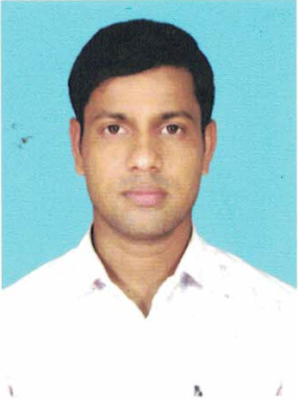

**Information** Father’s Name : NARAYAN SARKAR

**Personal** Date of Birth : 15/02/1992

Mobile No. : 9733463258

e-Mail Id : chhotonsarkar92@gmail.com

Marital Status : Single

Nationality : Indian

**Academic Qualification**

* Passed Madhyamik in the year of 2009 with 51% from **W.B.B.S.E.**
* Passed Higher Secondary in the year 2012 with 39% from **W.B.C.H.S.E.**
* Passed B.A. (PASS) in the year 2016 with 44% from **U.G.B.**

**Technical Skill**

* Basic Knowledge of Computer
* Microsoft **Excel** and **Word**
* Having good presentation skill using **Power Point**
* Sound knowledge of photo editing use of **Photoshop**
* All online activates, including various examination from fill up, ticket booking etc.

**Experience**

* Fresher
* Yoga and Athletics teaching

**Hobbies**

* Listening Music
* Use Computer
* Sports (Yoga, Badminton, Rokit Ball, Khokho, Kabaddi, March-pase, Athletics)

**Language Known**

* Bengali Read Write Speak
* English Read Write ……..
* Hindi Read ……. Speak

**Address**

Present & Permanent Address

Vill : New 16 Mile P.O. : Gurutola

P.S. : Baishnabnagar Dist : Malda

State : West Bengal Pin : 732127

**Objective**

To get a chance to work & utilize my knowledge and capabilities by working in a dynamic organization that prides it’s in giving substantial responsibility to new talent.

**Place : Signature**

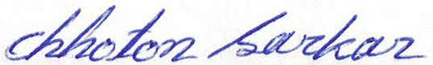

**Date :**