**Sumana Ray**

**Passionate, Enthusiastic, Confident**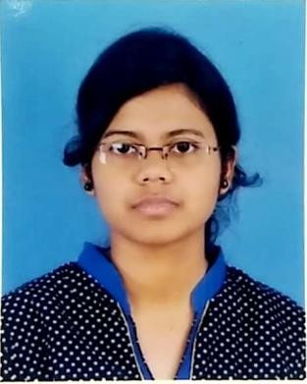

## Academics –

1. **Barlow Girls’ High School(Malda,WB)** Personal details**-**

* **Secondary(10th) DOB- 12th feb 1998**
* **Year-2014 Sex-female**
* **Percentage-69 Caste- Hinduism**

1. **Barlow Girls’High School (Malda,WB)** Languages-

* **Higher Secondary(12th) 1.Bengali(Mother tongue)**
* **Year-2016 2.English(Speak,read,write)**
* **Stream-Arts 3.Hindi(Speak & read)**
* **Percentage-82.40**

## 

**3.Malda college (Malda,WB)** Skills

* **Bachelor of Arts(B.A) Passionate**
* **Year-2019 Enthusiastic**
* **Honours in Bengali Literature Fast learner**
* **Percentage-60.12 Communication skill**

**Time management**

1. **UNIVERSITY of GOUR BANGA (Malda,WB) Team management**

* **Master of Arts(M.A) Confident**
* **Year- 2021 Friendly**
* **Masters in Bengali language & literature Tolerant**
* **Percentage-68.41 Calm**

Additional qualificationsHobby & Interest

**Diploma at computer application(DCA ) 1. Writing articles**

**Typing speed-35wpm 2. Reading literature**

**3. Cooking**

**4. Giving Honorary tuition**

# Contact details

**Address-South Ramkrishnapally,Malda(WB)**

**Malda- 732101**

* **Mobile-8509483618**
* **Email-** [**sumanaray100@gmail.com**](mailto:sumanaray100@gmail.com)
* **Whatsapp-9091096358**

“I Sumana Ray hereby declare that all the information provided by me is correct, true and valid. I will present the supporting documents as and when required.

Sumana ray

Date- 26.01.23