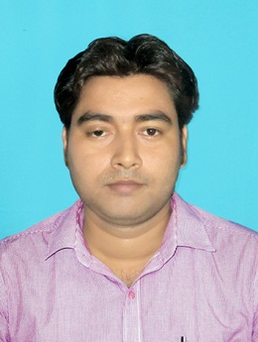**RESUME**

NAME : **BISWAJIT SARKAR**

CONTACT NO : 9547111842

EMAIL ID : [pv.biswajit.kitu@gmail.com](mailto:pv.biswajit.kitu@gmail.com)

RESIDENTIAL ADDRESS : Vill. – Jahangirpur,

PO- Jahangirpur, PS- Kotwali,

Dist.- Nadia, Pin- 741103

**OBJECTIVE**

Looking for an opportunity where I can utilize my knowledge and skills for my and company’s future growth

**EDUCATIONAL QUALIFICATION**

|  |  |  |  |
| --- | --- | --- | --- |
| **NAME OF EXAMINATION** | **UNIVERSITY / COUNCIL / BOARD** | **YEAR** | **% OF MARKS** |
| Madhyamik | W.B.B.S.E. | 2007 | 65% |
| Higher Secondary | W.B.C.H.S.E. | 2009 | 73% |
| Graduation (Snsk .Hons.) | University of Kalyani | 2012 | 68.5% |
| M.A. (Snsk. ) | Jadavpur University | 2014 | 52% |
| B.Ed. | University of Kalyani | 2015 | 78% |
| M.A. (Education) | N.S.O.U. | 2018 | 66% |

**ADDITIONAL QUALIFICAITON**

* Advance Diploma In Computer Application (18 months).

**EXPERIENCE**

* 1 year experience as a Guest Lecturer in Renuka Devi D.El.Ed. college.
* 2 years’ experience as a Head Master in Pranabananda Vidyapith High School organized by Bharat Sevashram Sangha at Aurangabad, Murshidabad.

**EXTRA CURRICULUM ACTIVITIES**

* Speaking Power, Debate, Energetic,

**COMPUTER SKILLS**

* MS Office package, Windows 7, 10, Internet.

**LANGUAGE KNOWN**

* English
* Bengali
* Hindi

**PERSONAL INFORMATION**

FATHER’S NAME : Goutam Sarkar

MOTHER’S NAME : Bandana Sarkar

DATE OF BIRTH : 19th March, 1990

NATIONALITY : Indian

RELIGION : Hinduism

CAST : General

MARITAL STATUS : Married

GENDER : Male

HOBBY ; Reading Books, Traveling new places.

**DECLARATION :**

I hereby declare that all the statements made in this application is true and correct I also understand that in the event of any statement furnished or documents attach is / are found false or in correct, it should this qualify my candidature and if detected after my appointment, my service will be liable to be terminated without notice.

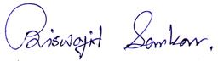

Date : 25.12.19

Place : Krishnagar

Signature